

Oracle Real Application Clusters(RAC) installation guide 19c, on Linux RHEL 7

Prepared by DBA Team, BoA
November, 2021
Table of Contents
1. RHEL 7 installation 2
2. Download Software i.e Oracle19c 2
3. Pre-installation configuration 2
Setting OS Hostname 2
Configuring /etc/resolv.conf file 2
Disable NetworkManager 3
Chrony Configuration 3
Oracle Database 19c Package Requirements 4
Configuring Security-Enhanced Linux (SELinux) 6
Configuring Firewall Settings 6
Modifying Kernel Parameters 6
User Accounts & Groups 7
Setting Shell Limits for the Grid and Oracle User 8
Disable Transparent Huge pages (THP) 10
Create a customized tuned profile with disabled THP 11
Edit .bash_profile for both grid and oracle 12
Prepare /u01 for binaries installation (Prepare as ext4 filesystem lvm) 13
Enabling SCSI_ID on VMware VM, for ASM disk groups 15
Create Udev rules for Oracle ASM using disk id and names 17
4. Installing Oracle Grid Infrastructure 19c 18
Step by Step Installation 19
5. Installing Oracle Database 19c Software 26
6. Creating ASM Disk groups via the ASM Configuration Assistant (ASMCA) 32
7. Creating Databases using Database Configuration Assistant (DBCA) 34
8. References 44

RHEL 7 installation
When we create the virtual machine as per the following requirements
CPU 8- 12…………as per the requirnmnet
MEMORY - 32GB....48………. as per the requirnmnet
DISK 1 - For OS 100GB which is /dev/sda
DISK 2 - For Oracle binaries which is /dev/sdb
Network 1 - database vlan (10.1.15.0) - Public IP(10.3.15.100)
Network 2 - dbtodb vlan (10.1.24.0) - Private IP(10.3.24.100)
Default scsi conroller is for os and binary
Install RHEL 7 using BoA installation guide. Download Oracle19c Software
Download the Oracle software from OTN or MOS depending on your support status.
- OTN: Oracle Database 19c (19.3) Software (64-bit)
- edelivery: Oracle Database 19c (19.3) Software (64-bit)

Pre-installation configuration

Setting OS Hostname
To set a hostname for a server use the hostnamectl command. An example of setting DB1-MGMT.bankofabyssinia.com hostname is shown below.
# hostnamectl set-hostname DB1-MGMT.bankofabyssinia.com
Verify the status:
# hostnamectl status
The "/etc/hosts" file must contain a fully qualified name for the server in the form of:
<IP-address> <fully-qualified-machine-name> <machine-name>
10.3.15.12 DB1-MGMT.bankofabyssinia.com DB1-MGMT
# cat /etc/sysconfig/network
NETWORKING=yes
HOSTNAME=DB1-MGMT.bankofabyssinia.com
NOZEROCONF=YES

Configuring /etc/resolv.conf file
The resolver is a set of routines in the C library that provides access to the Internet Domain Name System (DNS). An example of the /etc/resolv.conf file used on the reference environment is shown below.
# cat /etc/resolv.conf
# Generated by NetworkManager
search bankofabyssinia.com
nameserver 10.3.18.4
nameserver 10.1.18.4

Disable NetworkManager
# service NetworkManager stop
# chkconfig NetworkManager off
# service network restart

Chrony Configuration
The chronyd — is a daemon for synchronization of the system clock. It can synchronize the clock with NTP servers, reference clocks (e.g. a GPS receiver), and manual input using wristwatch and keyboard via chronyd.
If package not installed, install chrony via yum as follows:
# mkdir /mnt/cdrom
# mount /dev/cdrom /mnt/cdrom
# cp /mnt/cdrom/media.repo /etc/yum.repos.d/rhel7dvd.repo
# chmod 644 /etc/yum.repos.d/rhel7dvd.repo
Edit the new repo file, changing the gpgcheck=0 setting to 1 and adding the following 3 lines
enabled=1
baseurl=file:///mnt/cdrom/
gpgkey=file:///etc/pki/rpm-gpg/RPM-GPG-KEY-redhat-release
Clear the related caches by yum clean all
# yum repolist all
# yum clean all
# yum install chrony
Edit the /etc/chrony.conf file with a text editor such as vi and add your ntp servers.
# vi /etc/chrony.conf
server ntp1.bankofabyssinia.com iburst
server ntp2.bankofabyssinia.com iburst

Save all the changes within the /etc/chrony.conf file and start the chronyd daemon via the command:
# systemctl start chronyd.service
Ensure that the chronyd daemon is started when the host is booted.
# systemctl enable chronyd.service
Verify the chronyd daemon status.
# systemctl status chronyd.service

Oracle Database 19c Package Requirements
Run the following package installation commands to install the required packages.
yum install -y bc
yum install -y gcc
yum install -y gcc-c++
yum install -y binutils
yum install -y compat-libcap1
yum install -y compat-libstdc++-33
yum install -y dtrace-modules
yum install -y dtrace-modules-headers
yum install -y dtrace-modules-provider-headers
yum install -y dtrace-utils
yum install -y elfutils-libelf
yum install -y elfutils-libelf-devel
yum install -y fontconfig-devel
yum install -y glibc
yum install -y glibc-devel
yum install -y ksh
yum install -y libaio
yum install -y libaio-devel
yum install -y libdtrace-ctf-devel
yum install -y libXrender
yum install -y libXrender-devel
yum install -y libX11
yum install -y libXau
yum install -y libXi
yum install -y libXtst
yum install -y libgcc
yum install -y librdmacm-devel
yum install -y libstdc++
yum install -y libstdc++-devel
yum install -y libxcb
yum install -y make
yum install -y net-tools # Clusterware
yum install -y nfs-utils # ACFS
yum install -y python # ACFS
yum install -y python-configshell # ACFS
yum install -y python-rtslib # ACFS
yum install -y python-six # ACFS
yum install -y targetcli # ACFS
yum install -y smartmontools
yum install -y sysstat
yum install -y unixODBC
yum install -y net-tools
yum install -y xterm
yum install -y xclock
yum install -y nfs-utils
yum install -y smartmontools
yum install -y unzip
yum install -y unixODBC
yum install -y unixODBC-devel
yum install -y zlib-devel
yum install -y zlib-devel.i686
yum install -y psmisc
yum install –y xorg-x11-utils
yum install –y xorg-x11-xauth

For RAC install the following packages
yum install binutils -y
yum install compat-libstdc++-33 -y
yum install compat-libstdc++-33.i686 -y
yum install gcc -y
yum install gcc-c++ -y
yum install glibc -y
yum install glibc.i686 -y
yum install glibc-devel -y
yum install glibc-devel.i686 -y
yum install ksh -y
yum install libgcc -y
yum install libgcc.i686 -y
yum install libstdc++ -y
yum install libstdc++.i686 -y
yum install libstdc++-devel -y
yum install libstdc++-devel.i686 -y
yum install libaio -y
yum install libaio.i686 -y
yum install libaio-devel -y
yum install libaio-devel.i686 -y
yum install libXext -y
yum install libXext.i686 -y
yum install libXtst -y
yum install libXtst.i686 -y
yum install libX11 -y
yum install libX11.i686 -y
yum install libXau -y
yum install libXau.i686 -y
yum install libxcb -y
yum install libxcb.i686 -y
yum install libXi -y
yum install libXi.i686 -y
yum install make -y
yum install sysstat -y
yum install unixODBC -y
yum install unixODBC-devel -y
yum install zlib-devel -y
yum install zlib-devel.i686 -y

Configuring Security-Enhanced Linux (SELinux)
SELinux is an implementation of a mandatory access control (MAC) mechanism developed by the National Security Agency (NSA). The purpose of SELinux is to apply rules on files and processes based on defined policies.
It is highly recommended that SELinux be kept in ENFORCING mode when running Oracle Database 12c Release 2.
Verify that SELinux is running and set to ENFORCING:
As the root user,
# sestatus
If the system is running in PERMISSIVE or DISABLED mode, modify the /etc/selinux/config file and set SELinux to enforcing as shown below.
SELINUX=enforcing
The modification of the /etc/selinux/config file takes effect after a reboot. To change the setting of SELinux immediately without a reboot, run the following command:
# setenforce 1

Configuring Firewall Settings
Firewall access and restrictions play a critical role in securing your Oracle Database 12c Release 2 environment. The use of Red Hat Enterprise Linux 7 introduces the use of firewalld, a dynamic firewall daemon, instead of the traditional iptables service. firewalld works by assigning network zones to assign a level of trust to a network and its associated connections and interfaces⁶. The key difference and advantage of firewalld over the iptables service is it does not require flushing of the old firewall rules to apply the new firewall rules.
To turn off the firewall
# systemctl status firewalld.service
# systemctl stop firewalld.service
# chkconfig firewalld off
# systemctl disable firewalld.service

Modifying Kernel Parameters
The following sections regarding virtual memory, shared memory, semaphores, network ports, I/O synchronous requests, file handles, and kernel panic on OOPS parameters.
Create a file labeled 98-oracle-kernel.conf within /etc/sysctl.d/
# vi 98-oracle-kernel.conf
vm.swappiness = 10
vm.dirty_background_ratio = 3
vm.dirty_ratio = 15
vm.dirty_expire_centisecs = 500
vm.dirty_writeback_centisecs = 100
fs.file-max = 6815744
kernel.sem = 250 32000 100 128
kernel.shmmni = 4096
kernel.shmall = 1073741824
kernel.shmmax = 4398046511104
kernel.panic_on_oops = 1
net.core.rmem_default = 262144
net.core.rmem_max = 4194304
net.core.wmem_default = 262144
net.core.wmem_max = 1048576
net.ipv4.conf.all.rp_filter = 2
net.ipv4.conf.default.rp_filter = 2
fs.aio-max-nr = 1048576
net.ipv4.ip_local_port_range = 9000 65500
For the changes to take effect immediately, run the following command:
# sysctl -p /etc/sysctl.d/98-oracle-kernel.conf

User Accounts & Groups
Prior to the installation of Oracle Database 12c Release 2, Oracle recommends the creation of a grid user for the Oracle Grid Infrastructure and an oracle user for the Oracle Database software installed on the system.
For the purposes of this reference environment, the Oracle Grid Infrastructure owner is the user grid and the Oracle Database software owner is the user oracle. Each user is designated different groups to handle specific roles based on the software installed. However, the creation of separate users requires that both the oracle user and the grid user have a common primary group, the Oracle central inventory group (OINSTALL).
As the root user, create the following user accounts, groups, and group assignments using a consistent UID and GID assignments across your organization:
groupadd --gid 54321 oinstall
groupadd --gid 54322 dba
groupadd --gid 54323 asmdba
groupadd --gid 54324 asmoper
groupadd --gid 54325 asmadmin
groupadd --gid 54326 oper
useradd --uid 54321 --gid oinstall --groups dba,oper,asmdba,asmoper oracle
passwd oracle
useradd --uid 54322 --gid oinstall --groups dba,asmadmin,asmdba,asmoper grid
passwd grid
Verify the oracle and grid user correctly display the appropriate primary and supplementary groups via the commands:
# id oracle
uid=54321(oracle) gid=54321(oinstall) groups=54321(oinstall),54322(dba),54323(asmdba),54326(oper),54324(asmoper)

# id grid
uid=54322(grid) gid=54321(oinstall) groups=54321(oinstall),54322(dba),
54323(asmdba),54324(asmoper),54325(asmadmin

Setting Shell Limits for the Grid and Oracle User
Oracle recommends the following settings for the soft and hard limits for the number of open file descriptors (nofile), number of processes (nproc), and size of the stack segment (stack) allowed by each user respectively. The purpose of setting these limits is to prevent a system wide crash that could be caused if an application, such as Oracle, were allowed to exhaust all of the OS resources under an extremely heavy workload.
Create a file labeled 99-grid-oracle-limits.conf within /etc/security/limits.d/ as follows:
# vi /etc/security/limits.d/99-grid-oracle-limits.conf
Note
The reason that the /etc/security/limits.conf file is not directly modified is due to the order in which limit files are read in the system. After reading the /etc/security/limits.conf file, files within the /etc/security/limits.d/ directory are read. If two files contain the same entry, the entry read last takes precedence.
Within the /etc/security/limits.d/99-grid-oracle-limits.conf file, add the following soft and hard limits for the oracle and grid user:
oracle soft nofile 1024
oracle hard nofile 65536
oracle soft nproc 16384
oracle hard nproc 16384
oracle soft stack 10240
oracle hard stack 32768
oracle hard memlock 134217728
oracle soft memlock 134217728
grid soft nofile 1024
grid hard nofile 65536
grid soft nproc 16384
grid hard nproc 16384
grid soft stack 10240
grid hard stack 32768
grid hard memlock 134217728
grid soft memlock 134217728
Due to Bug 1597142116, the soft limit of nproc is not adjusted at runtime by the Oracle database. Due to this, if the nproc limit is reached, the Oracle database may become unstable and not be able to fork additional processes. A high enough value for the maximum number of concurrent threads for the given workload must be set, or use the hard limit value of 16384 as done above if in doubt.
Note
Modifications made to the 99-grid-oracle-limits.conf file take effect immediately. However, please ensure that any previously logged in oracle or grid user sessions (if any) are logged out and logged back in for the changes to take effect.
As the root user, create a shell script labeled oracle-grid.sh within /etc/profile.d/ to create the ulimits for the oracle and grid user. The contents of the oracle-grid.sh script:
#Setting the appropriate ulimits for oracle and grid user
if [ $USER = "oracle" ]; then
if [ $SHELL = "/bin/ksh" ]; then
ulimit -u 16384
ulimit -n 65536
else
ulimit -u 16384 -n 65536
fi
fi
if [ $USER = "grid" ]; then
if [ $SHELL = "/bin/ksh" ]; then
ulimit -u 16384
ulimit -n 65536
else
ulimit -u 16384 -n 65536
fi
fi
Note
While the ulimit values can be set directly within the /etc/profile file, it is recommended to create a custom shell script within /etc/profile.d instead.
As oracle and grid user, verify the ULIMIT values by running the following command:
# ulimit –a

Tuned and udev

Disable Transparent Huge pages (THP)
“tuned.service” on RHEL 7 set the transparent_hugepage to always by default. Even if its disabled in grub kernel command line, the tuned service will set it to ‘always‘ during boot. Below command output confirm that the THP are enabled on the system.
# cat /sys/kernel/mm/transparent_hugepage/enabled
[always] madvise never
To disable THP
Add the “transparent_hugepage=never” kernel parameter option to the grub2 configuration file. Append or change the “transparent_hugepage=never” kernel parameter on the GRUB_CMDLINE_LINUX option in /etc/default/grub file.
# vi /etc/default/grub
GRUB_TIMEOUT=5
GRUB_DISTRIBUTOR="$(sed 's, release .\*$,,g' /etc/system-release)"
GRUB_DEFAULT=saved
GRUB_DISABLE_SUBMENU=true
GRUB_TERMINAL_OUTPUT="console"
GRUB_CMDLINE_LINUX="rd.lvm.lv=myvg/swap rd.lvm.lv=myvg/usr
vconsole.font=latarcyrheb-sun16 rd.lvm.lv=myvg/root crashkernel=auto
vconsole.keymap=us rhgb quiet transparent_hugepage=never"
GRUB_DISABLE_RECOVERY="true"
Rebuild the /boot/grub2/grub.cfg file by running the grub2-mkconfig -o command. Before rebuilding the GRUB2 configuration file, ensure to take a backup of the existing /boot/grub2/grub.cfg.
# grub2-mkconfig -o /boot/grub2/grub.cfg
Reboot the system and verify option are in effect.
# reboot
# cat /sys/kernel/mm/transparent_hugepage/enabled
always madvise [never]
If Transparent Huge Pages (THP) is still not disabled, continue and use one of the options below.
Disable the tuned services if it is re-enabling the THP using either of the below commands.
# systemctl stop tuned
# systemctl disable tuned
OR
# tuned-adm off

Create a customized tuned profile with disabled THP
Another and recommended way is to create a customized tuned profile with THP disabled. Find out which profile is active, create a copy. In the following example we currently use the throughput-performance profile:
# tuned-adm active
Current active profile: throughput-performance
To create customized profile, create a new directory in /etc/tuned directory with desired profile name.
# mkdir /etc/tuned/nothp_profile
# cd /etc/tuned/nothp_profile
Then create a new tuned.conf file for nothp_profile, and insert the new tuning info:
The following parameters are commented out due to higher values being used by Red Hat Enterprise Linux 7.1 or higher with a default installation. The list includes:
#kernel.shmmax = 4398046511104
#kernel.shmall = 1073741824
#kernel.shmmni = 4096
#fs.file-max = 6815744
#kernel.panic_on_oops = 1
Example of tuned.conf
#
# tuned configuration
#

[main]
summary=Optimize for Oracle RDBMS
include=throughput-performance

[sysctl]
vm.swappiness = 10
vm.dirty_background_ratio = 3
vm.dirty_ratio = 15
vm.dirty_expire_centisecs = 500
vm.dirty_writeback_centisecs = 100
fs.file-max = 6815744
kernel.sem = 250 32000 100 128
kernel.shmmni = 4096
kernel.shmall = 1073741824
kernel.shmmax = 4398046511104
kernel.panic_on_oops = 1
net.core.rmem_default = 262144
net.core.rmem_max = 4194304
net.core.wmem_default = 262144
net.core.wmem_max = 1048576
net.ipv4.conf.all.rp_filter = 2
net.ipv4.conf.default.rp_filter = 2
fs.aio-max-nr = 1048576
net.ipv4.ip_local_port_range = 9000 65500

[vm]
transparent_hugepages=never
Make the script executable.
# chmod +x /etc/tuned/nothp_profile/tuned.conf
Enable nothp_profile using the tuned-adm command.
# tuned-adm profile nothp_profile
This change will immediately take effect and persist reboots. To verify if THP are disabled or not, run below command:
# cat /sys/kernel/mm/transparent_hugepage/enabled
always madvise [never]

Edit .bash_profile for both grid and oracle
Create environments for grid
export TMP=/tmp
export ORACLE_HOSTNAME=R17-DB1-MGMT.bankofabyssinia.com
export ORACLE_UNQNAME=+ASM
export ORACLE_BASE=/u01/app/grid
export ORACLE_HOME=/u01/app/grid/products/19.3.0/grid
export ORACLE_SID=+ASM

PATH=$PATH:$HOME/bin:$ORACLE_HOME/bin
export PATH

export LD_LIBRARY_PATH=$ORACLE_HOME/lib:/lib:/usr/lib;
export CLASSPATH=$ORACLE_HOME/jlib:$ORACLE_HOME/rdbms/jlib;
Create environment for oracle
export TMP=/tmp

export ORACLE_HOSTNAME=R17-DB1-MGMT.bankofabyssinia.com
export ORACLE_UNQNAME=t24prod
export ORACLE_BASE=/u01/app/oracle
export ORACLE_HOME=$ORACLE_BASE/product/19.3.0/dbhome_1
export ORACLE_SID=t24prod

PATH=$PATH:$HOME/bin:$ORACLE_HOME/bin
export PATH

export LD_LIBRARY_PATH=$ORACLE_HOME/lib:/lib:/usr/lib;
export CLASSPATH=$ORACLE_HOME/jlib:$ORACLE_HOME/rdbms/jlib;

umask 022

Prepare /u01 for binaries installation (Prepare as ext4 filesystem lvm)
[oracle@T24-ORA19c-TEST ~]$ cat /proc/partitions
major minor #blocks name

8 0 104857600 sda
8 1 1048576 sda1
8 2 103808000 sda2
8 16 157286400 sdb
11 0 3963904 sr0
253 0 15728640 dm-0
253 1 16777216 dm-1
253 2 10485760 dm-2
253 3 29356032 dm-3
253 4 15728640 dm-4
253 5 15728640 dm-5
Step 1. fdisk /dev/sdb and create /dev/sdb1

[root@RHEL7 ~]# fdisk /dev/sdb
Welcome to fdisk (util-linux 2.23.2).
Changes will remain in memory only, until you decide to write them.
Be careful before using the write command.
Device does not contain a recognized partition table
Building a new DOS disklabel with disk identifier 0xd5cd330c.

Command (m for help): n
Partition type:
p primary (0 primary, 0 extended, 4 free)
e extended
Select (default p): p
Partition number (1-4, default 1): enter
First sector (2048-314572799, default 2048): enter
Using default value 2048
Last sector, +sectors or +size{K,M,G} (2048-314572799, default 314572799): enter
Using default value 314572799
Partition 1 of type Linux and of size 150 GiB is set
Command (m for help): w
The partition table has been altered!
Calling ioctl() to re-read partition table.
Syncing disks.
[root@RHEL7 ~]# ll /dev/sdb*
brw-rw----. 1 root disk 8, 16 Mar 17 14:54 /dev/sdb
brw-rw----. 1 root disk 8, 17 Mar 17 14:54 /dev/sdb1
Step 2. pvcreate /dev/sdb1
Step 3. vgcreate u01_vg /dev/sdb1
Step 4. lvcreate -L148G -n u01_lv u01_vg
Step 5. lvs
Step 6. mkfs.ext4 /dev/u01_vg/u01_lv
Step 7. Create parent directory for mount point
[root@RHEL7 ~]# mkdir -p /u01
Step 8. Add to /etc/fstab for permanent change
[root@RHEL7 ~]# vi /etc/fstab
/dev/mapper/u01_vg-u01_lv /u01 ext4 defaults 0 0
Step 9. mount -a
[root@T24-ORA19c-TEST ~]# df -h
Filesystem Size Used Avail Use% Mounted on
/dev/mapper/rhel_t24--ora19c--test-root 15G 74M 14G 1% /
devtmpfs 79G 0 79G 0% /dev
tmpfs 79G 0 79G 0% /dev/shm
tmpfs 79G 8.6M 79G 1% /run
tmpfs 79G 0 79G 0% /sys/fs/cgroup
/dev/mapper/rhel_t24--ora19c--test-usr 9.8G 1.3G 8.0G 14% /usr
/dev/sda1 976M 95M 815M 11% /boot
/dev/mapper/rhel_t24--ora19c--test-tmp 15G 41M 14G 1% /tmp
/dev/mapper/rhel_t24--ora19c--test-var 28G 135M 26G 1% /var
/dev/mapper/rhel_t24--ora19c--test-home 15G 41M 14G 1% /home
tmpfs 16G 0 16G 0% /run/user/0
/dev/mapper/u01_vg-u01_lv 146G 61M 139G 1% /u01

After the pre configuration Clone RAC2 from RAC1
Make those changes in RAC2
In /etc/sysconfig/network-scripts change Ip of the interfaces
In /etc/hostname change hostname
vi /etc/hosts
In /etc/sysconfig/network change hostname
In oracle and grid home .bash_profile edit the environment

Enabling SCSI_ID on VMware VM, for ASM disk groups ……..do this step on both RAC
To preserve the device names across reboots in Linux, udev rules is the recommended option. The idea is to extract SCSI device’s unique ID and assign it to a symbolic name that will persist across reboots. To get the SCSI device’s unique ID, Linux command scsi_id can be used.
On VMware, you might run into an issue where scsi_id did not return any results.
~]# /usr/lib/udev/scsi_id -g -u -d /dev/sdc
~]#
To fix this, you have to enable a VMX configuration named disk.EnableUUID to TRUE. You can accomplish this in two ways.
- Editing the VM’s vmx file
- Adding the option through VM’s settings in vCenter GUI.
Enabling through vCenter GUI
- Power off the VM
- Right click on the VM and select Edit Settings
- Select the VM Options tab, expand the Advanced option and click “Edit Configuration ..”
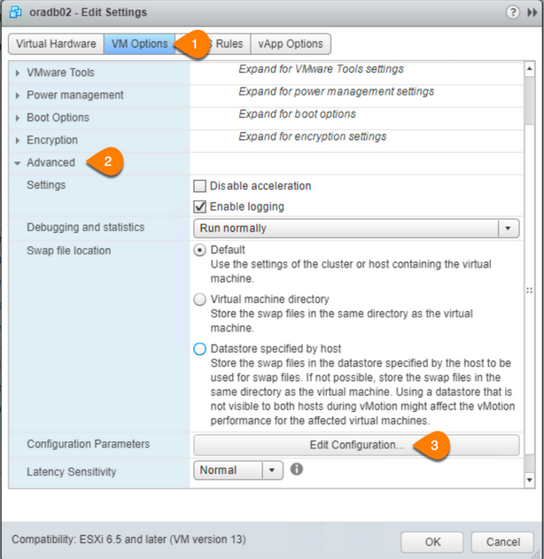
- At the bottom, enter disk.EnableUUID in the name field, TRUE in the value field and press Add and click OK.
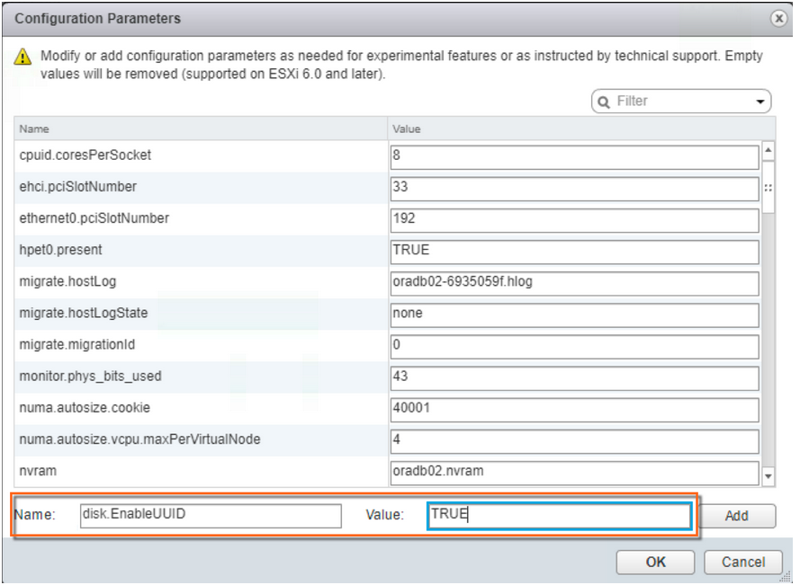
- Power On the VM
~]# /usr/lib/udev/scsi_id -g -u -d /dev/sdc
36000c291a090ed3953a582b1ed78fb02
~]#

Create Udev rules for Oracle ASM using disk id and names
Generate id/result by ~]# /usr/lib/udev/scsi_id -g -u -d /dev/sdc and add it in the /etc/udev/rules.d/99-oracle-asmdevices.rules file.
vi /etc/udev/rules.d/99-oracle-asmdevices.rules
udev content looks like
cat /etc/udev/rules.d/99-oracle-asmdevices.rules
KERNEL=="sd*", ENV{DEVTYPE}=="disk", SUBSYSTEM=="block", PROGRAM=="/usr/lib/udev/scsi_id --whitelisted --replace-whitespace --device=/dev/$name", RESULT=="36000c2969df6eca1aa12f90aa8fbf08c", SYMLINK+="REDO01", OWNER="grid", GROUP="asmadmin", MODE="0660"
KERNEL=="sd*", ENV{DEVTYPE}=="disk", SUBSYSTEM=="block", PROGRAM=="/usr/lib/udev/scsi_id --whitelisted --replace-whitespace --device=/dev/$name", RESULT=="36000c29f16e1505734fef5c6a59b9bbf" SYMLINK+="DATA01", OWNER="grid", GROUP="asmadmin", MODE="0660"
KERNEL=="sd*", ENV{DEVTYPE}=="disk", SUBSYSTEM=="block", PROGRAM=="/usr/lib/udev/scsi_id --whitelisted --replace-whitespace --device=/dev/$name", RESULT=="36000c292349505aea2d0eb2093a864e3" , SYMLINK+="DATA02", OWNER="grid", GROUP="asmadmin", MODE="0660"
.
.
.
Then execute the below commands to let know the OS changes you made.
]# /sbin/udevadm control --reload-rules
]# /sbin/udevadm trigger --type=devices --action=change
Add 5, 20GB each on rac1 vm with multitier setting with different scsi controller
Add second scsi controller for crsdg

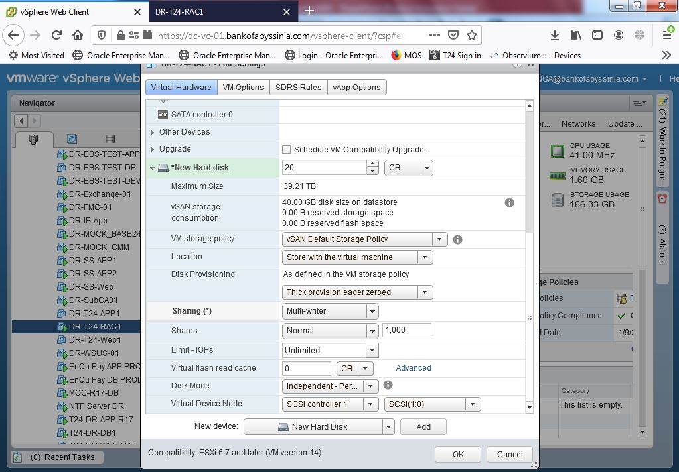
Add the above crsdg disks on rac2 as existing disk
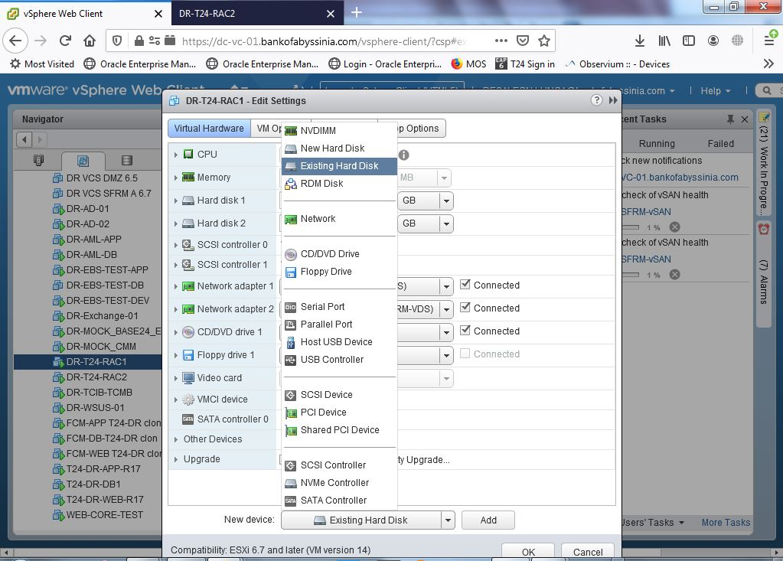

create this folder on both RAC mkdir --parents /u01/app/grid/products/12.2.0/grid

Installing Oracle Grid Infrastructure 19c
The following commands create the Grid home directory and set the appropriate permissions:
As the root user,
# mkdir --parents /u01/app/grid/products/19.3.0/grid
# chown --recursive grid.oinstall /u01
# cd <grid_download_location>
# chown grid.oinstall LINUX.X64_193000_grid_home.zip

Login as grid user
$ mv /path/LINUX.X64_193000_grid_home.zip /u01/app/grid/products/19.3.0/grid
$ cd /u01/app/grid/products/19.3.0/grid
$ unzip LINUX.X64_193000_grid_home.zip
Start the OUI via the command:
$ /u01/app/grid/products/19.3.0/grid/gridSetup.sh

Step by Step Installation
Within the Configuration Option window, select Configure Oracle Grid Infrastructure for a Standalone Server (Oracle Restart) and select Next.
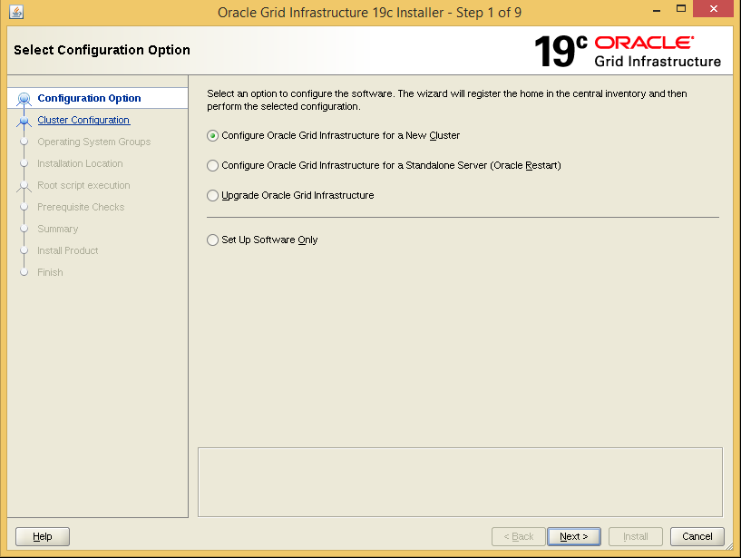

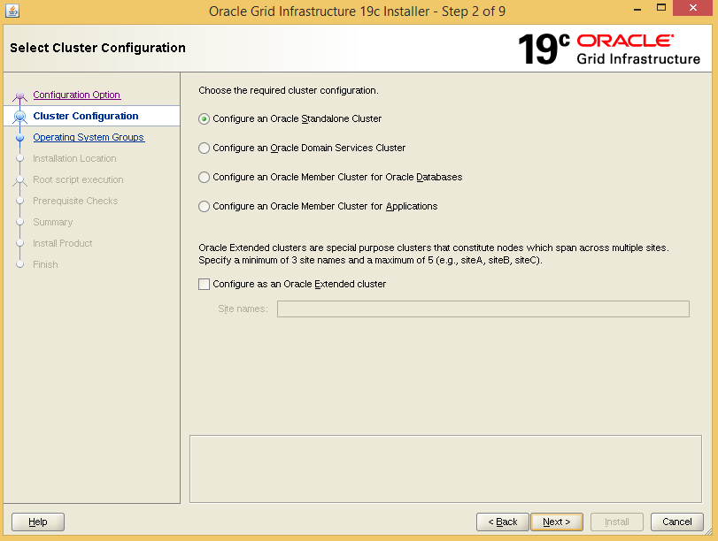

For the connection string give the scan name and port as follows:
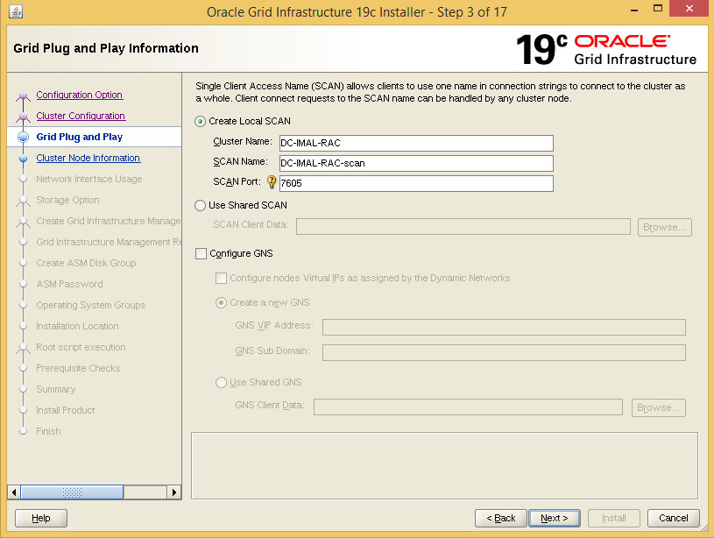

Click on ADD button to add the second node
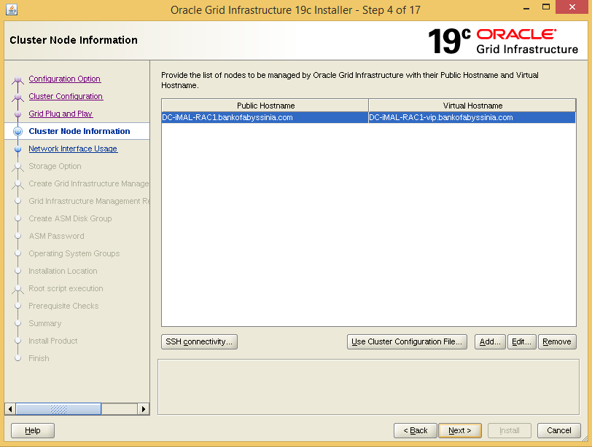

Give the public hostname and virtual IP Address Name then click ok then Next
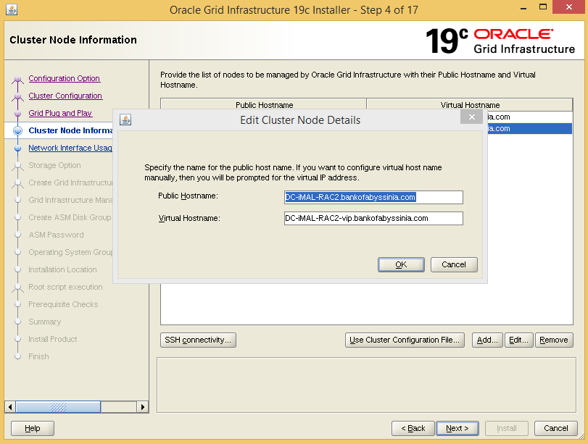

Click on SSH Connectivity to establish passwordless ssh connectivity

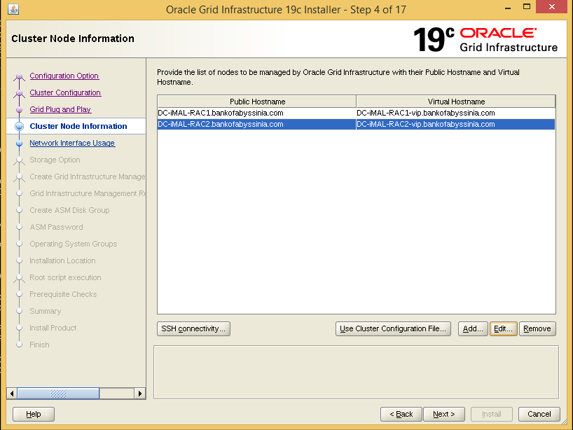

Enter the grid OS password then click on setup button

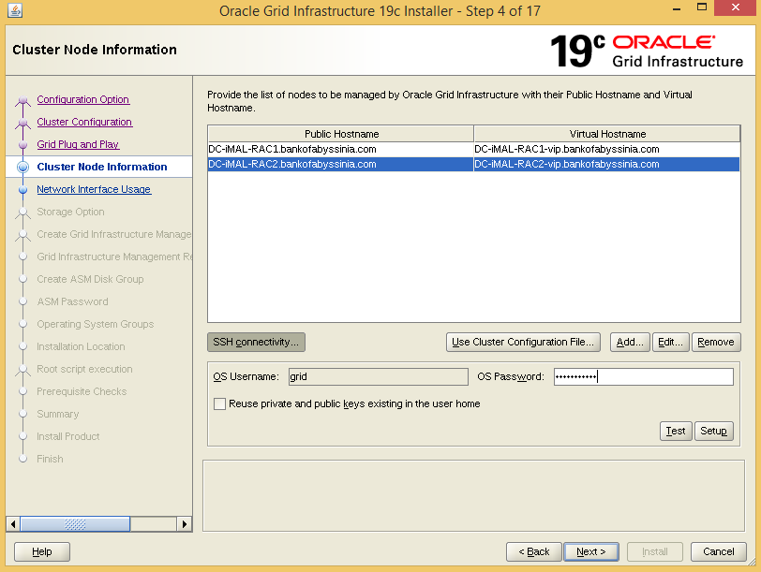

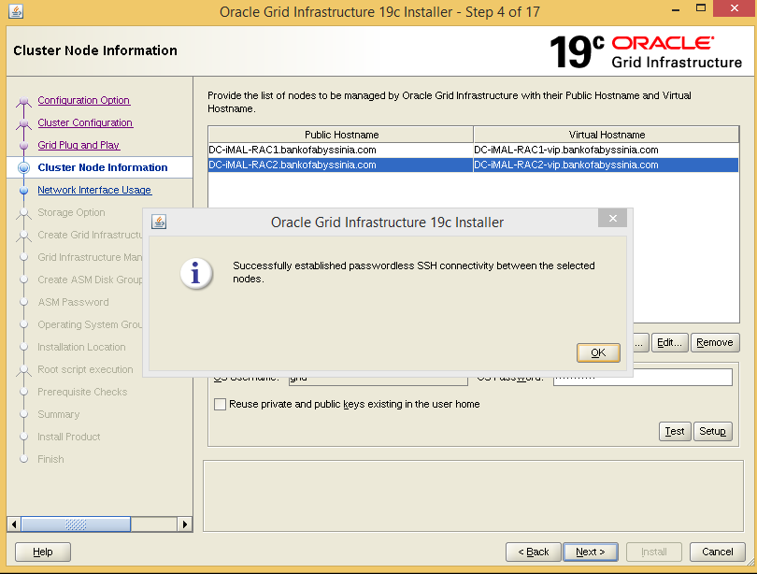

Private interface should be for ASM& private
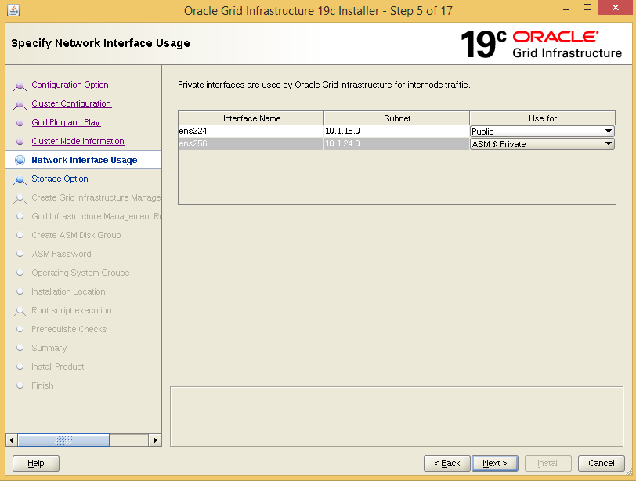

To configure OCR and voting disks on ASM storage click on Use Oracle Flex ASM for storage
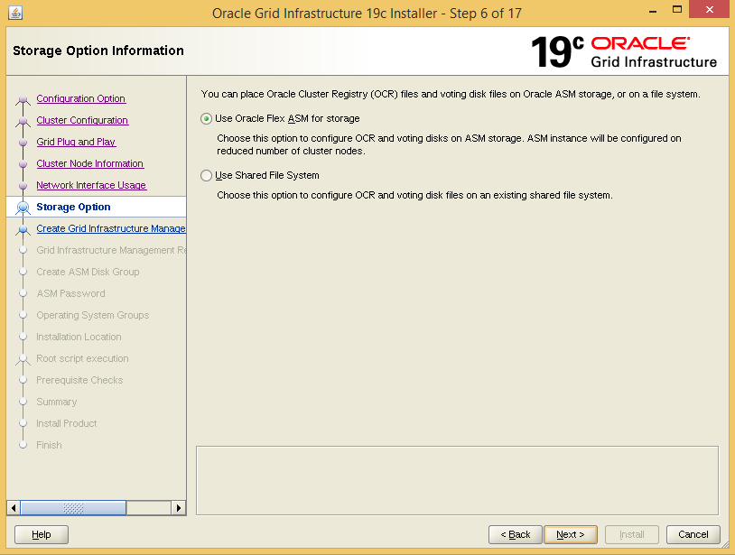

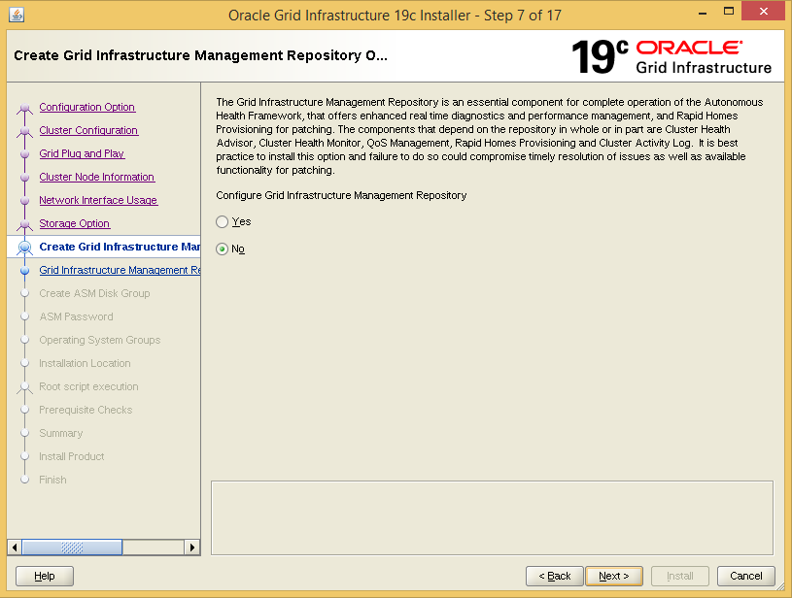

Add 5 disks for CRSDG Disk Group click Next
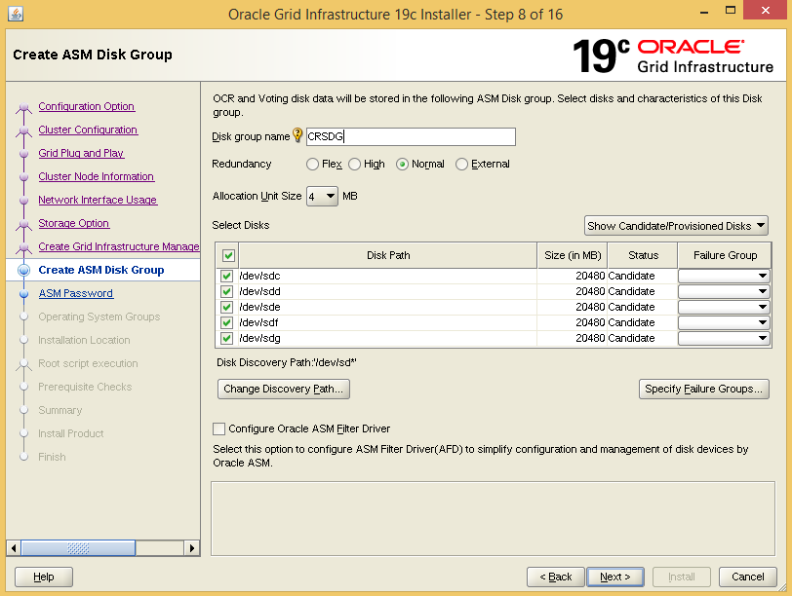

Specify password for the SYS and ASMSNMP user, click Next
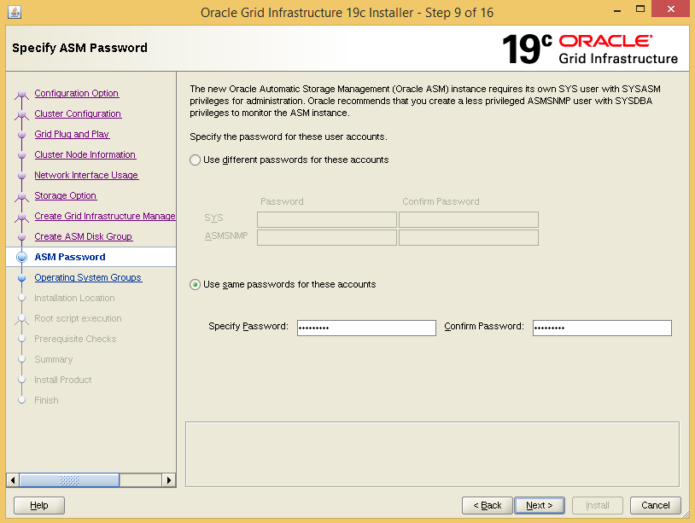
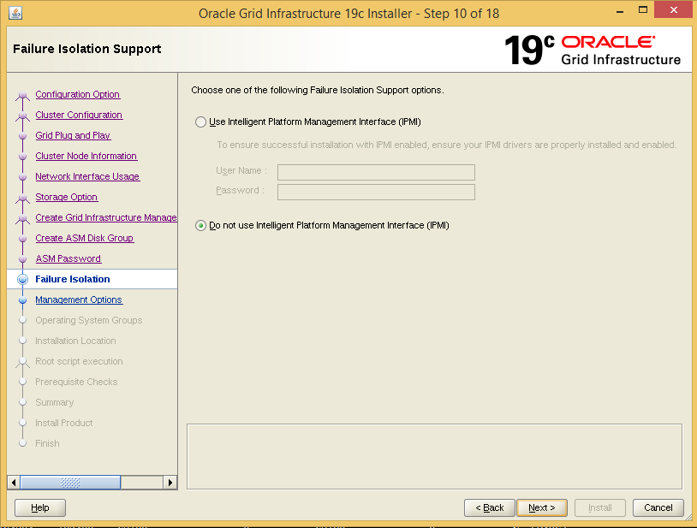

Uncheck Register with Enterprise Manager (EM) Cloud control, click Next
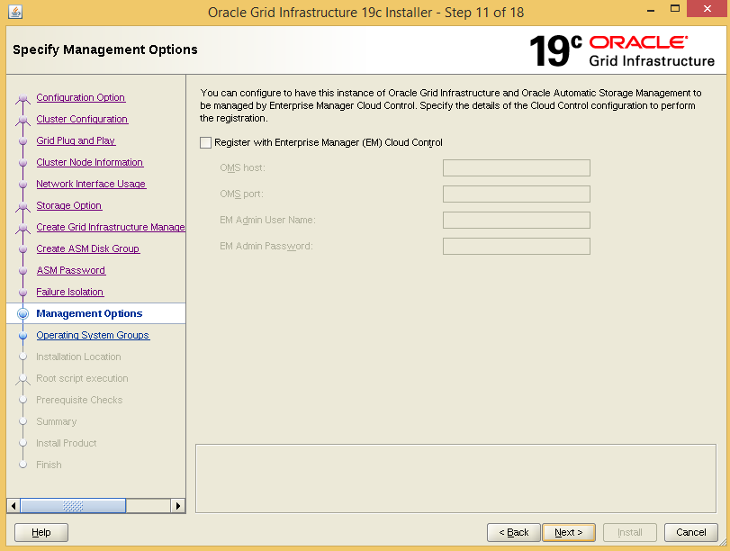

Select the appropriate OS groups and click Next.
- Oracle ASM Administrator Group – ASMADMIN
- Oracle ASM DBA Group – ASMDBA
- Oracle ASM Operator Group – ASMOPER

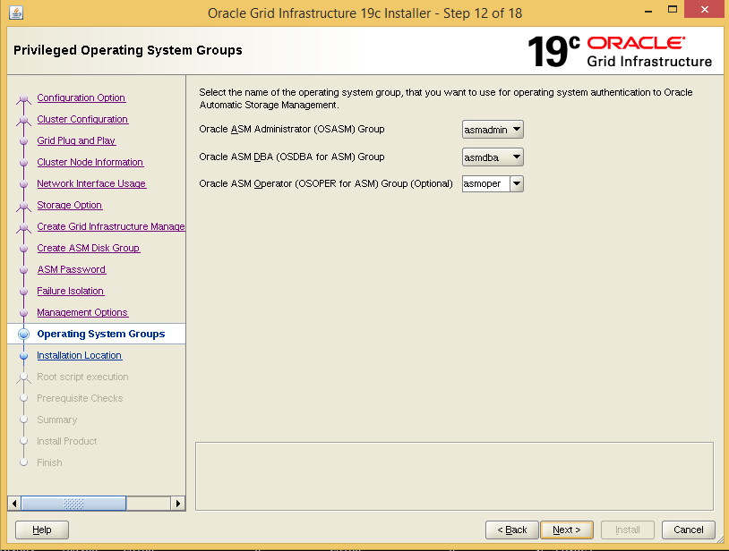

Within the Installation Location window, specify the appropriate Oracle base and software locations and click Next. The values set by this reference environment are as follows:
- Oracle base: /u01/app/gridb
- Software location: /u01/app/grid/products/19.3.0/grid

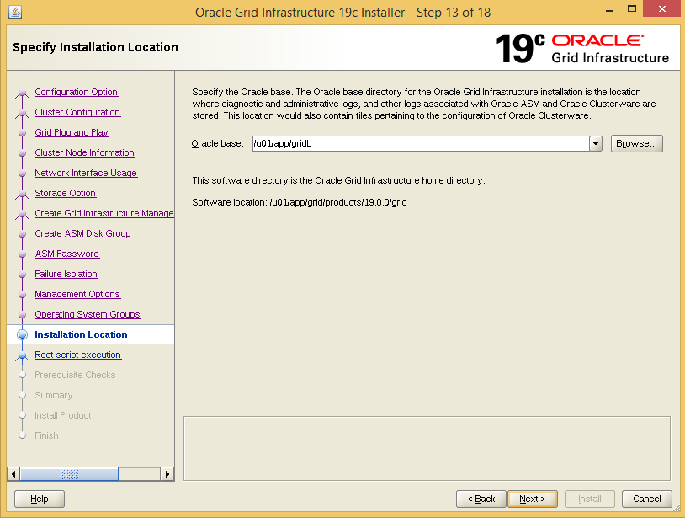

Within the Create Inventory window, specify the inventory directory and click Next. The values set by this reference environment are as follows:
- Inventory Directory - /u01/app/oraInventory

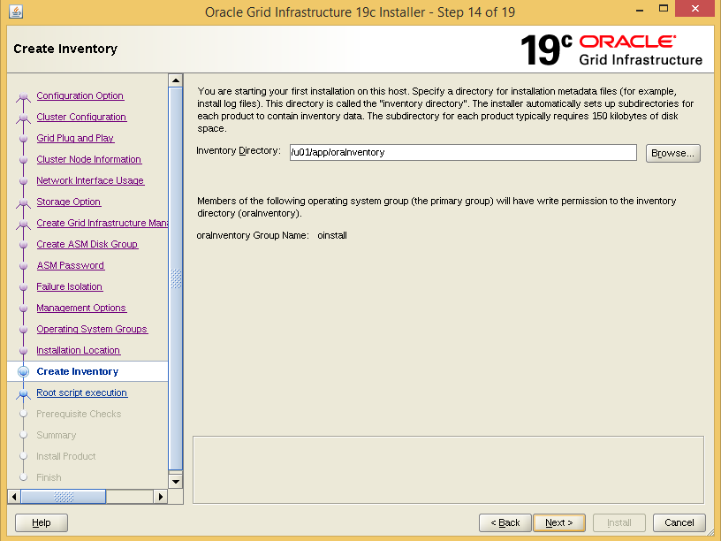

Within the Root script execution configuration window, click next you will execute the scripts manually by root user later
Uncheck Automatically run configuration scripts
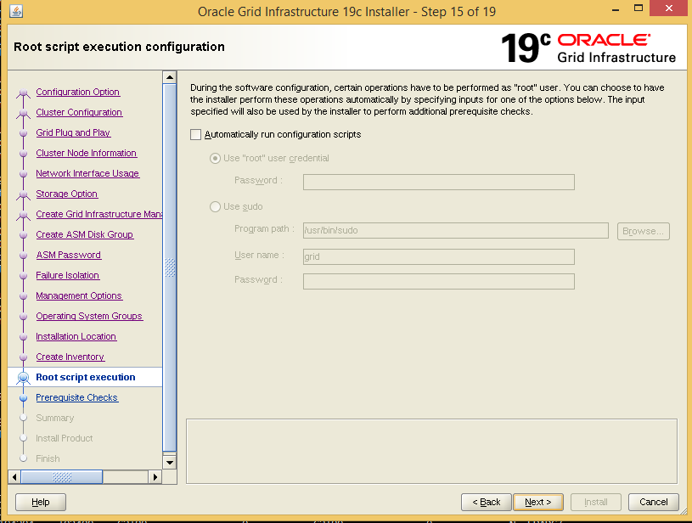

Within the Prerequisite Checks window, review the status and ensure there are no errors prior to continuing the installation. For failures with a status set to Fixable, select the Fix & Check Again button.

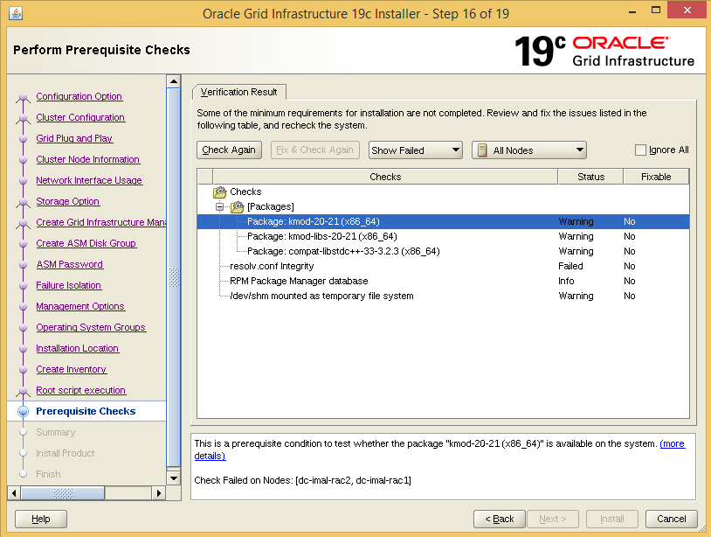
Then install manually the remaining packages as per the following
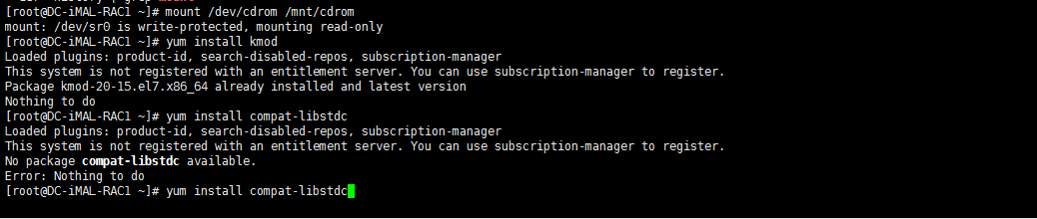

Click on Yes button then Next
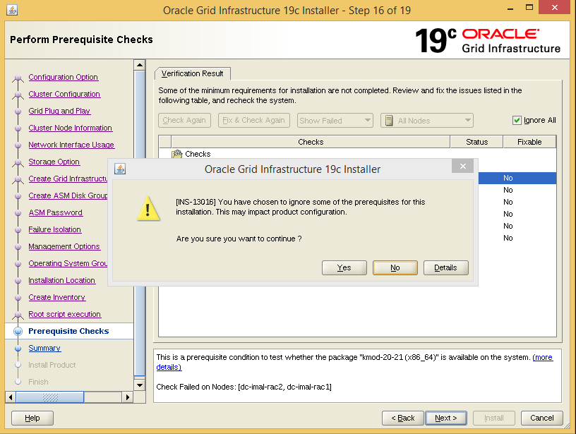

Within the Summary window, review all the information provided, and select Install to start the installation.

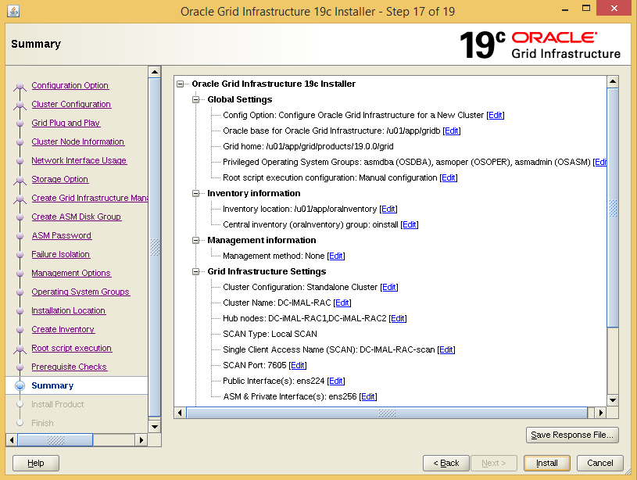
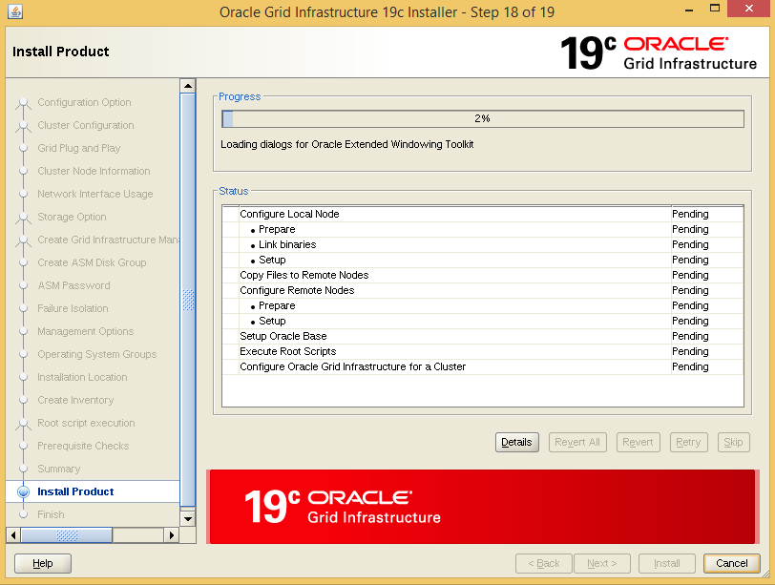

Run the following two scripts login as root user on both node.First on node 1 run both scripts do the same for node 2 then after execution click ok button
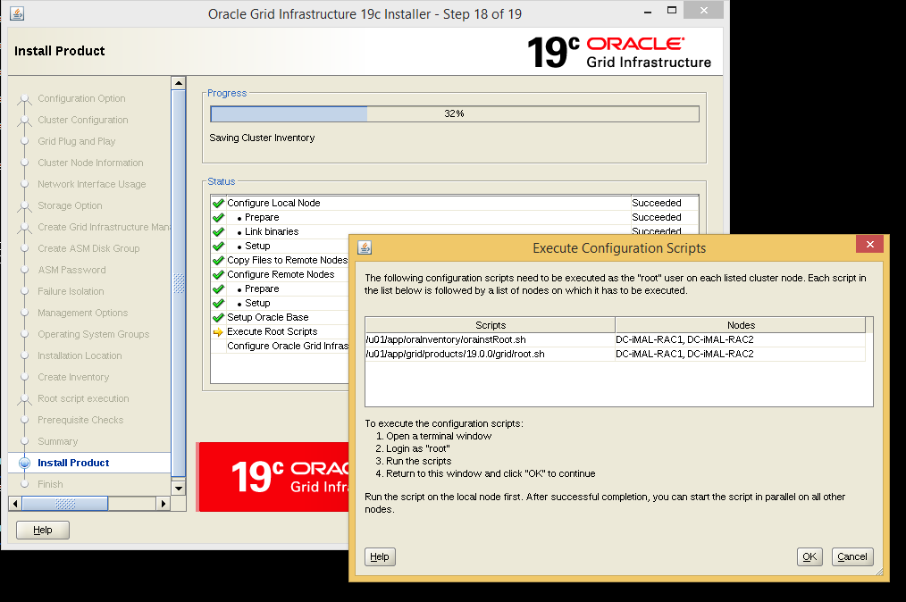
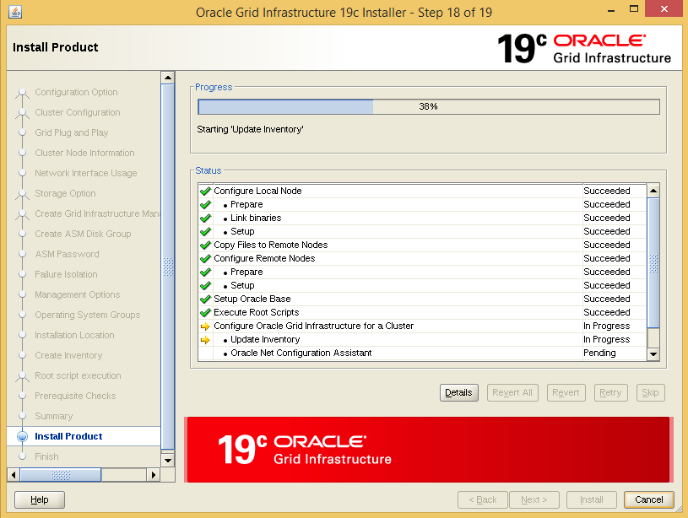

Within the Finish window, verify the installation was successful and click Close.

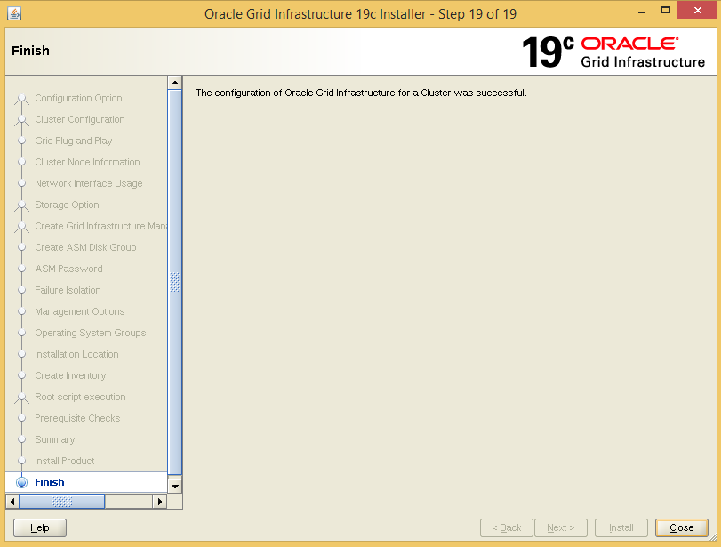

Installing Oracle Database 19c Software
The following commands create the Oracle base directory and set the appropriate permissions:
As the root user,
# mkdir --parents /u01/app/oracle
# chown --recursive oracle.oinstall /u01/app/oracle
Download the Oracle Database software file from the Oracle Software Delivery Cloud.
# cd <oracle_download_location>
# chown oracle.oinstall LINUX.X64_193000_db_home.zip
Login as oracle user,
$ mv /u01/LINUX.X64_193000_db_home.zip $ORACLE_HOME
$ cd $ORACLE_HOME
$ unzip LINUX.X64_193000_db_home.zip
$ /u01/app/oracle/product/19.3.0/dbhome_1/runInstaller
Within the Configure Security Updates window, provide the My Oracle Support email address for the latest security issues information. Otherwise uncheck the I wish to receive security updates via My Oracle Support and click Next.
Within the Installation Option window, select Set Up Software Only and click Next.
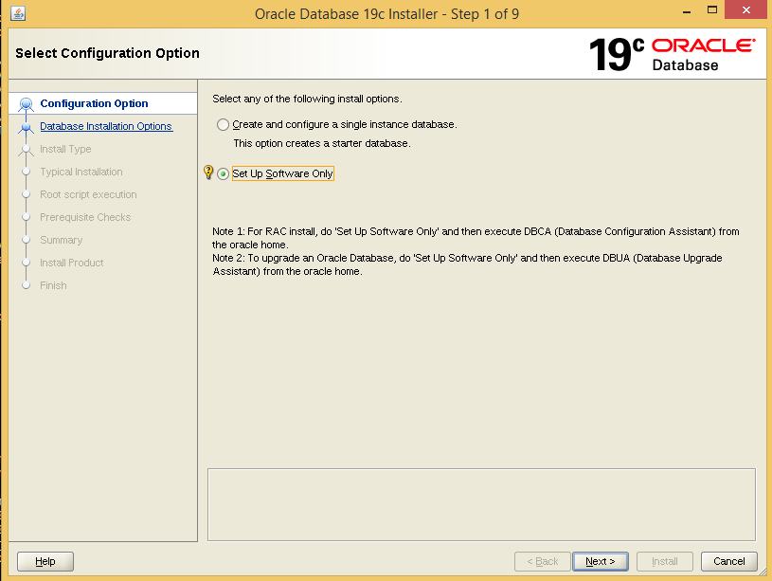

Within the Database Installation Options window, select oracle Real Application Clusters database installation as the type of database installation being performed and click Next.
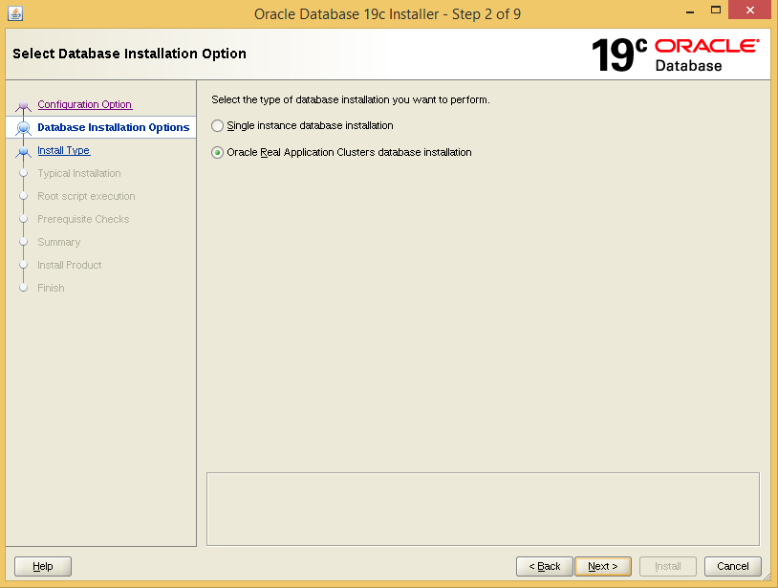

Click on SSH Connectivity for password less connectivity
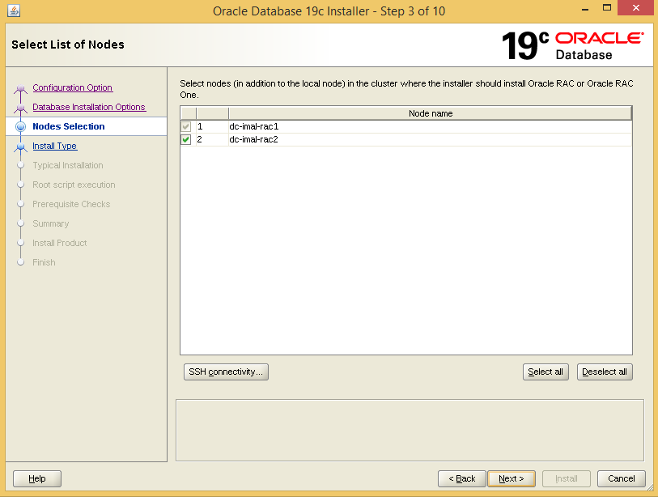

Enter OracleOS password then click on setup button
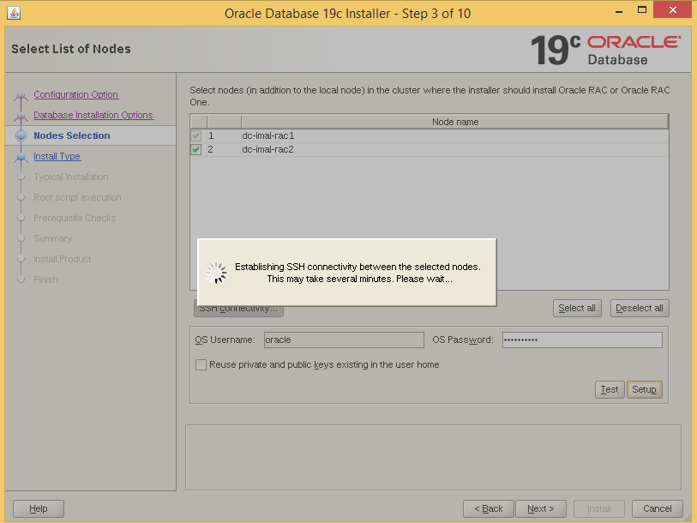

Within the Database Edition window, select the appropriate database edition and click Next. For the purposes of this reference environment, Enterprise Edition is the edition of choice
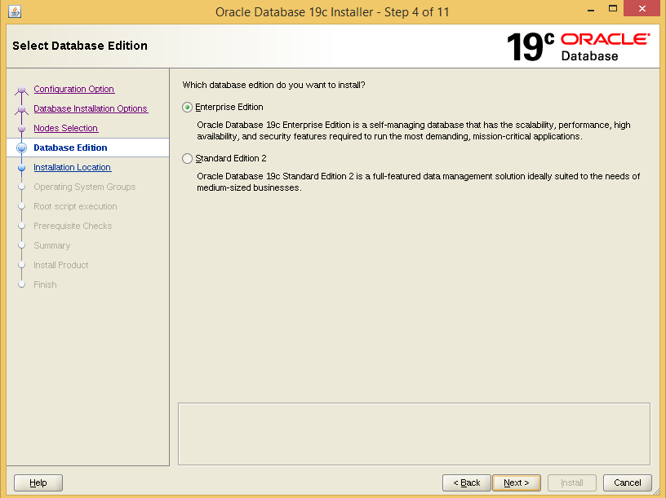
Within the Installation Location window, select the appropriate Oracle base and software location and click Next. For the purposes of this reference environment, the following values are set:
- Oracle base - /u01/app/oracle
- Software Location - /u01/app/oracle/product/19.3.0/dbhome_1

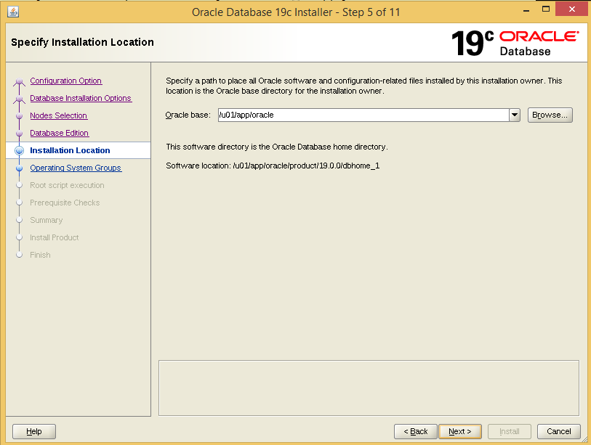

Within the Operating System Groups window, select the appropriate OS groups and click Next.

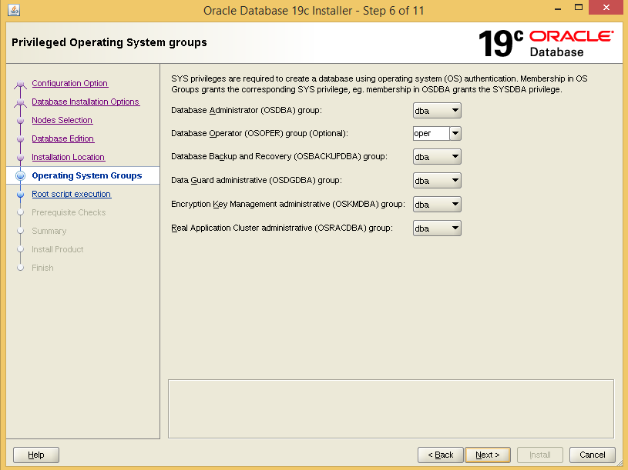

Within the Root script execution configuration window, click next you will execute the scripts manually by root user later
Uncheck Automatically run configuration scripts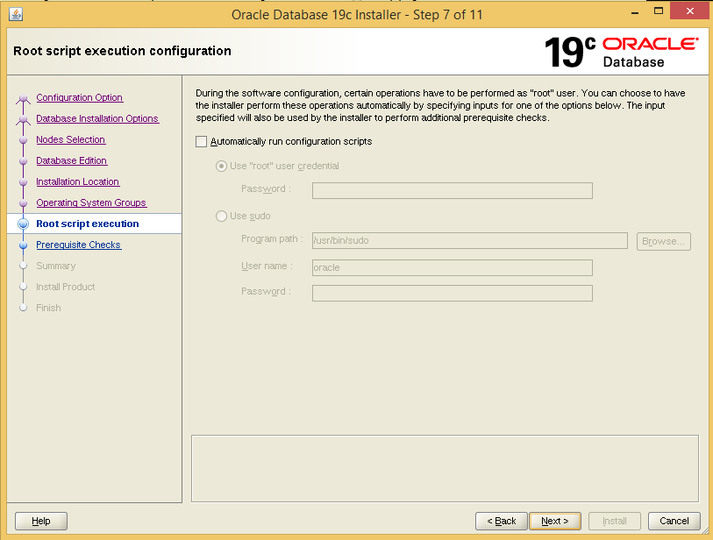

Minimum Requirement for installation should be completed
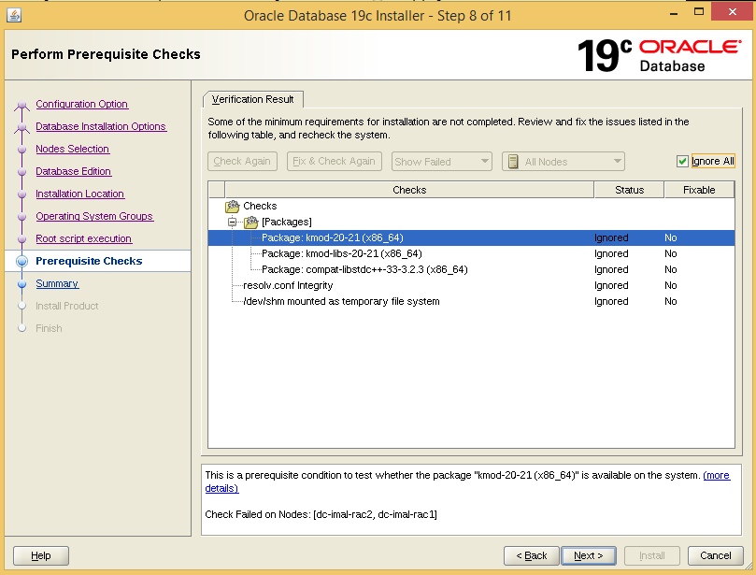

Within the Summary window, reviews all the information provided, and click Install to start the installation.
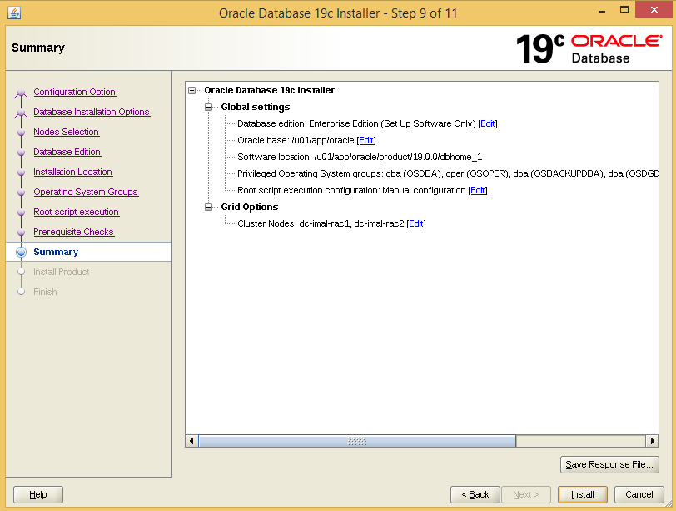

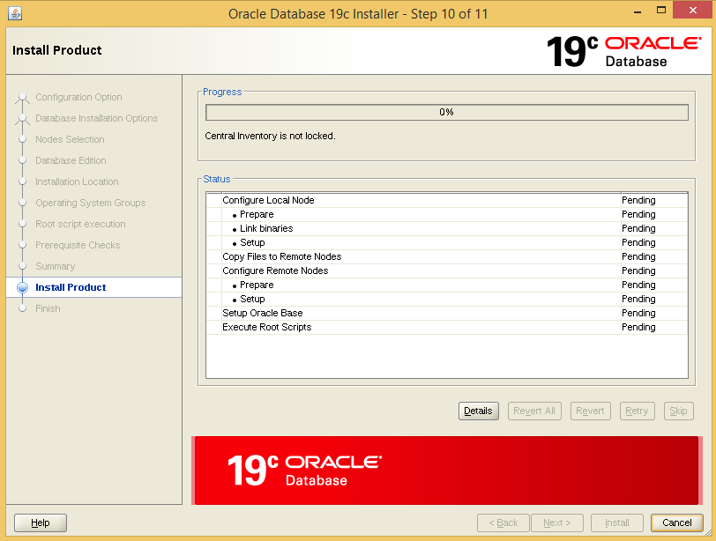
Execute the scripts within the Execute Configuration scripts window. As the root user, run the following:
# /u01/app/oracle/product/19.3.0/dbhome_1/root.sh
Click OK within the Execute Configuration scripts window.

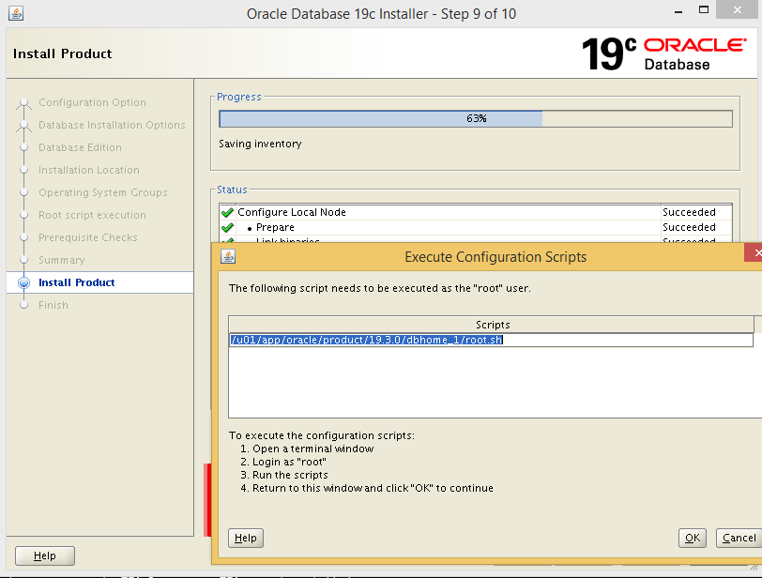
Within the Finish window, verify the installation was successful and click Close.

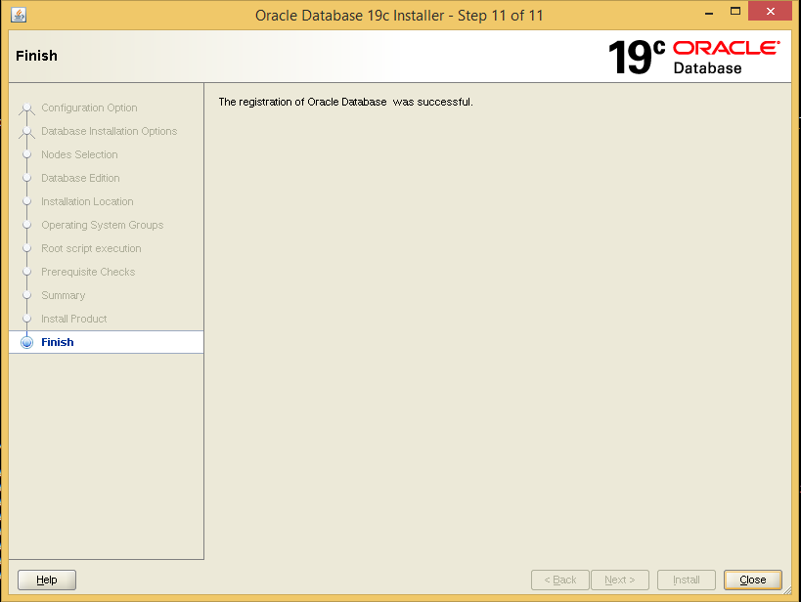

Creating ASM Disk groups via the ASM Configuration Assistant (ASMCA)

Add the disk for DATADG ,FRADG,REDO01DG,Redo02DG on rac1 vm with multitier setting with different scsi controller
Add the third scsi controller for DATADG
Add the fourth scsi controller for FRADG, REDO01DG, Redo02DG
Prior to the creation of an Oracle database, create other disk groups using Oracle ASM disk groups via Oracle’s ASM Configuration Assistant (ASMCA).

Login as grid user and start asmca via the following command:
$ /u01/app/grid/products/19.3.0/grid/bin/asmca
Via the asmca application, select the Disk Groups and click Create.
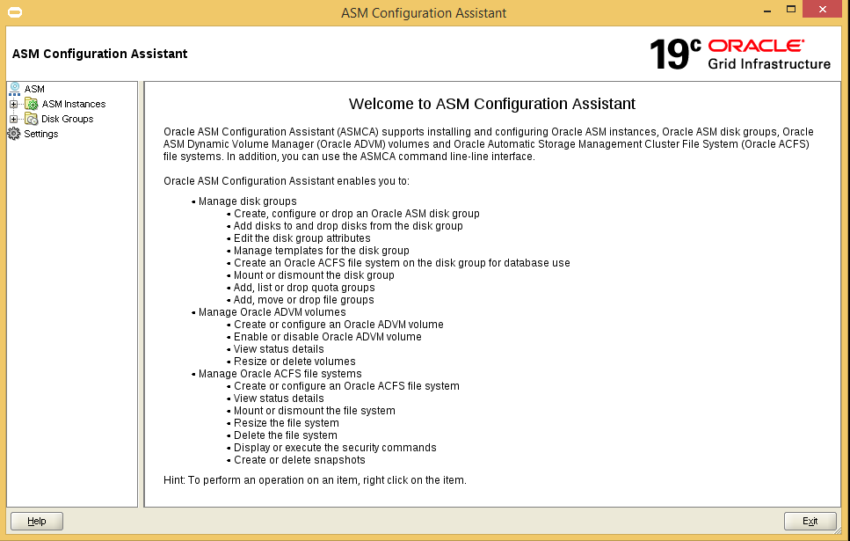
Within the Create Disk Group window, provide the following:
- A name for the disk group, i.e. REDO01DG
- Redundancy level for the disk group, i.e. External Redundancy
- Select an AU Size, i.e. 4 MB
Click the OK button once the steps above are complete.
Repeat the above steps to configure additional disk groups. It is recommended to create a disk group to separate the Redo logs.
Once all the disk groups are created, click the Exit button from the main ASM Configuration Assistant window. Click yes when asked to confirm quitting the application.

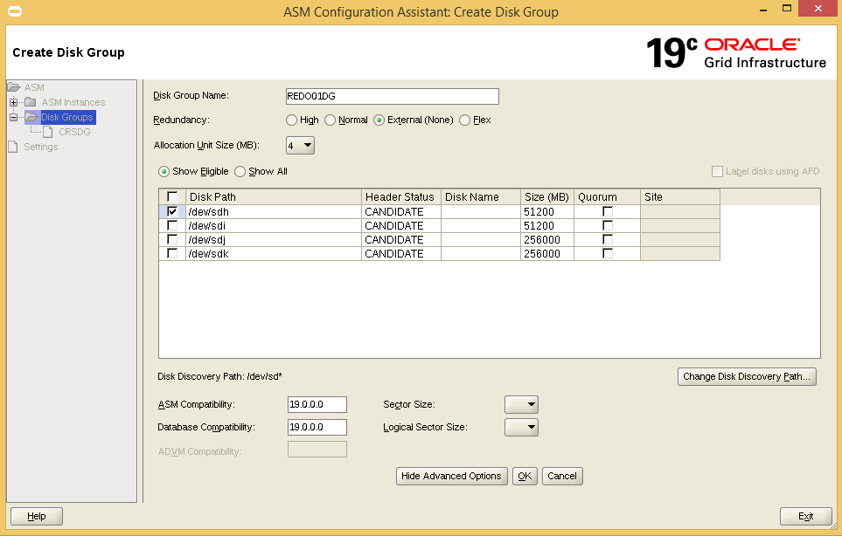
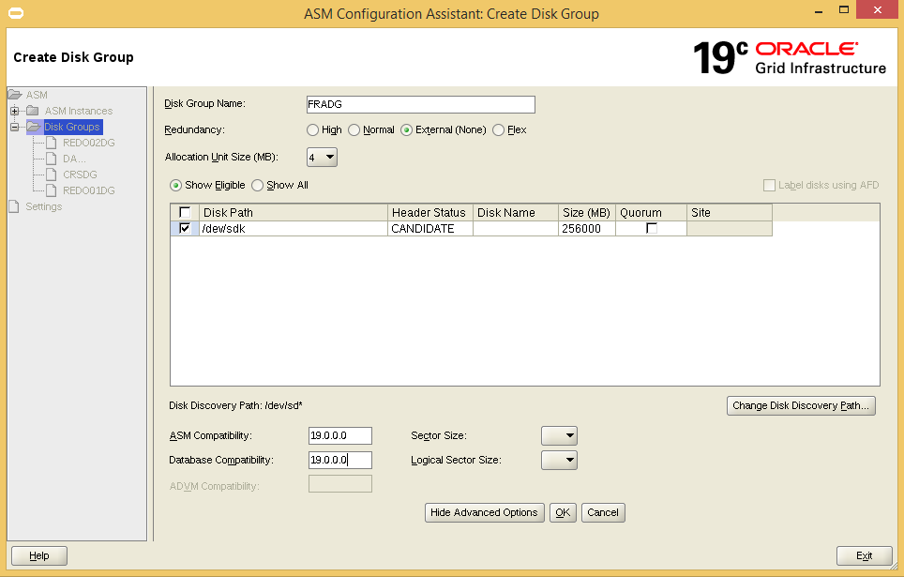

Creating Databases using Database Configuration Assistant (DBCA)
Login as the oracle user, run the dbca utility via the command:
$ /u01/app/oracle/product/19.3.0/dbhome_1/bin/dbca
Within the Database Operations window, select Create a database radio button and click Next.
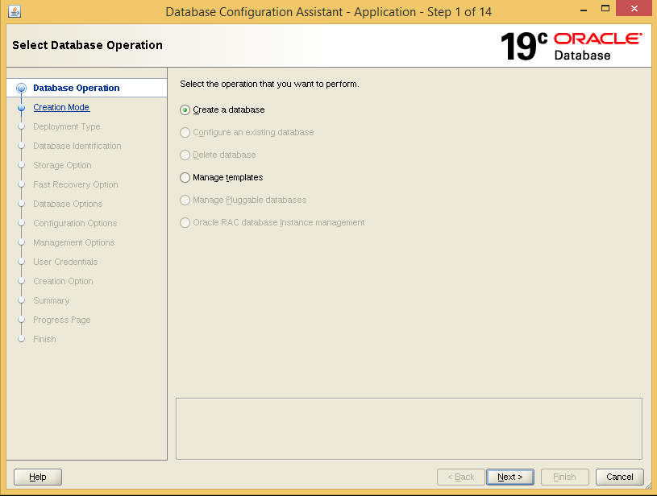
Within the Creation Mode window, select Advanced Mode radio button and click Next.
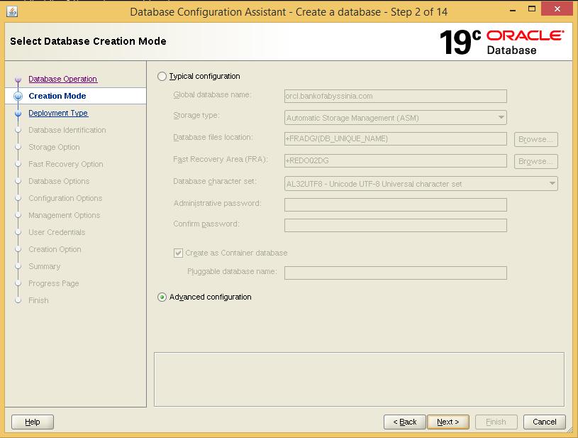

Within the Database Template window, select Database Type as Oracle Real Application cluster (RAC) database and Custom Database radio button. Click Next.
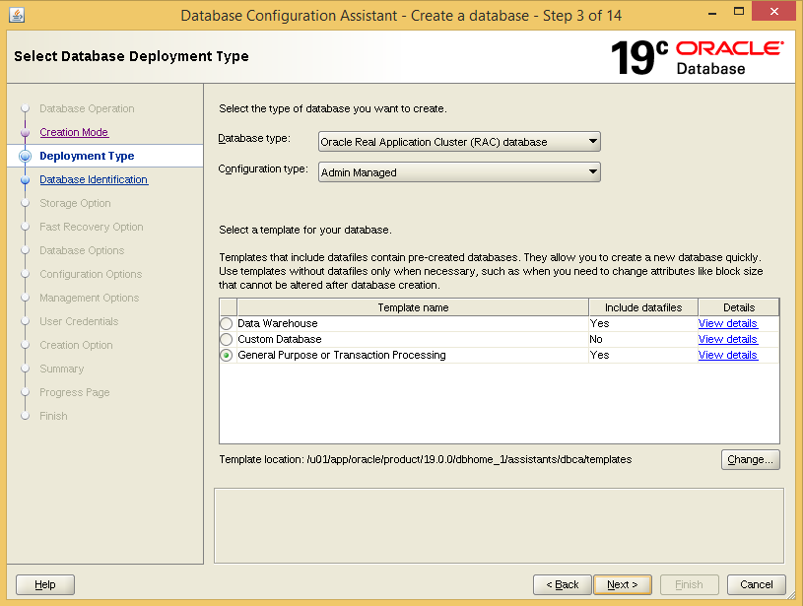

Select the nodes
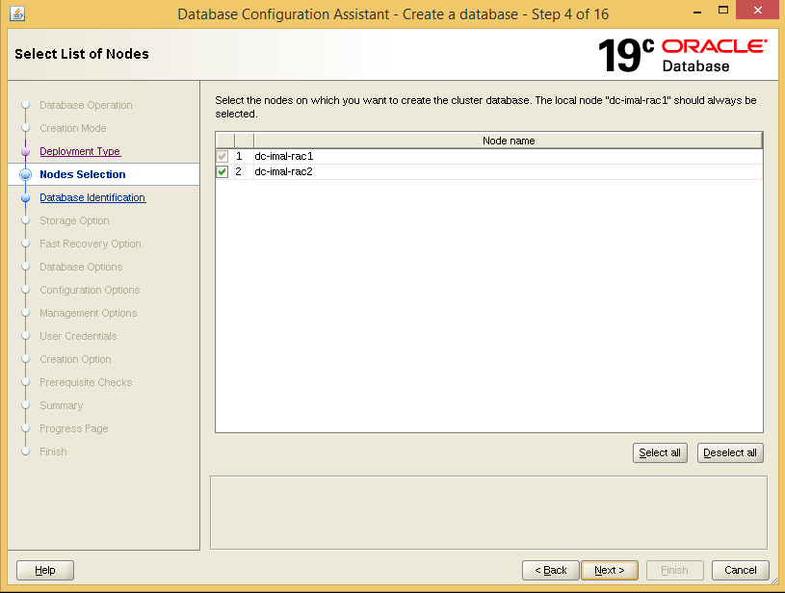

Within the Database Identification window, set a global database name and Oracle System Identifier (SID). Uncheck the check box that reads Create as Container Database and click Next.

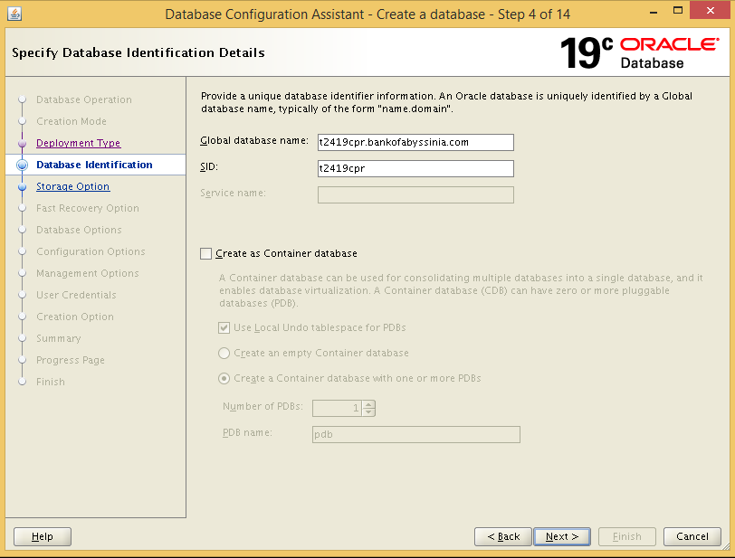
Within the Storage Option window, select Use following for the database storage attributes radio button. Change the Database file storage type: to Automatic Storage Management (ASM). Within the Database file location: select the Browse button and pick the database disk group, i.e. +DATADG. Select the Mutliplex redo logs and control files and enter the name of the redo log disk group (if created previously), i.e. +REDODG. Check the use of Oracle-Managed Files (OMF).
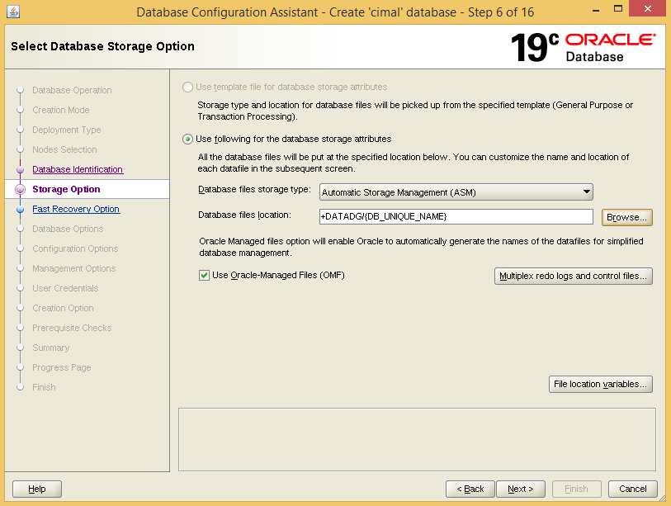

Within the Fast Recovery Option window, check the checkbox labeled Specify Fast Recovery Area, and select the Browse button to pick the diskgroup that is to be assigned for Fast Recovery Area, i.e. +FRADG. Enter an appropriate size based upon the size of the disk group.
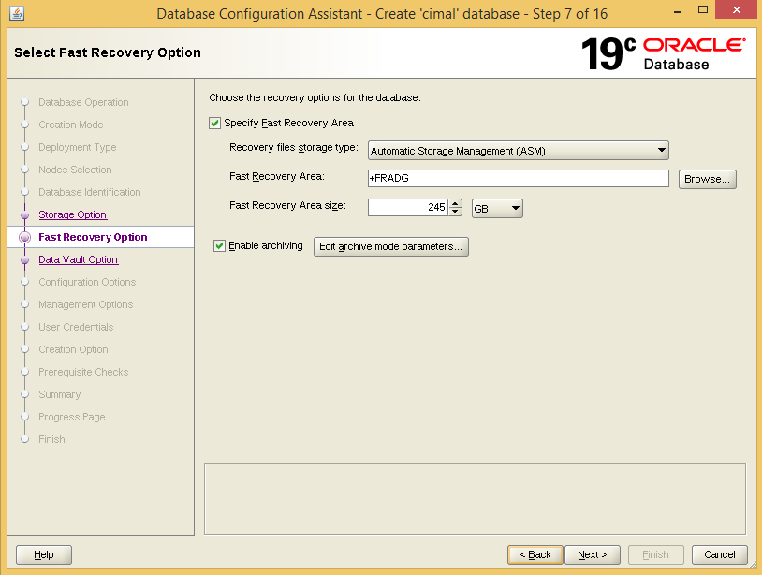

Uncheck configuration of Data Vault option
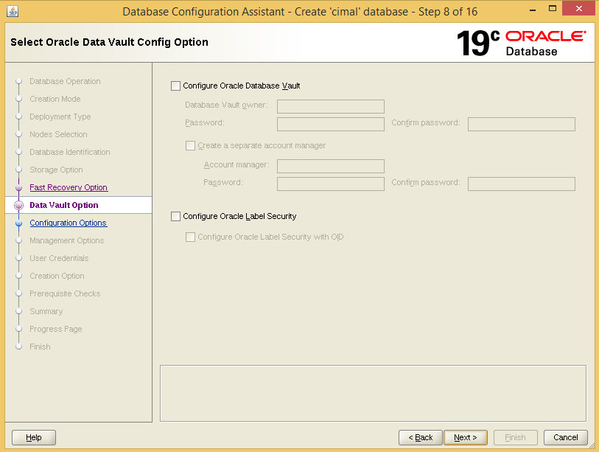

Within the Configuration Options window, ensure the Use Automatic Shared Memory Segment is selected, and use the scroll bar or enter the appropriate SGA and PGA values for the environment. The remaining tabs, Sizing, Character sets, Connection mode, the defaults are used.

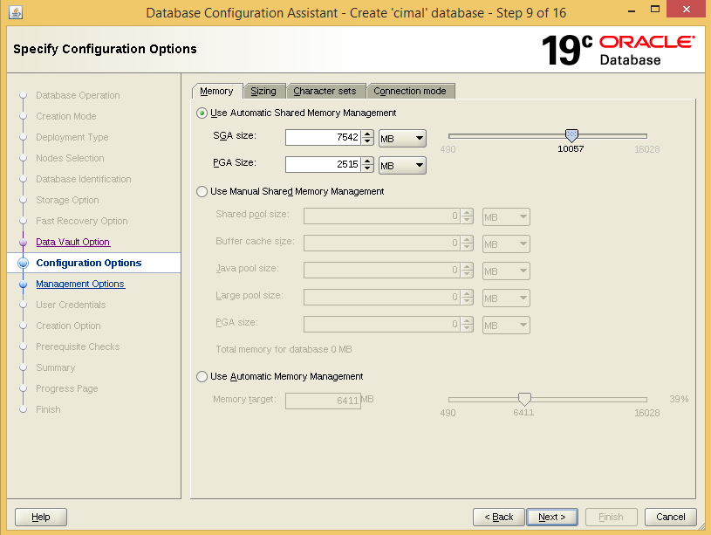

Within the Database Options window, select the database components to install. This reference environment kept the defaults. Once selected, click Next.
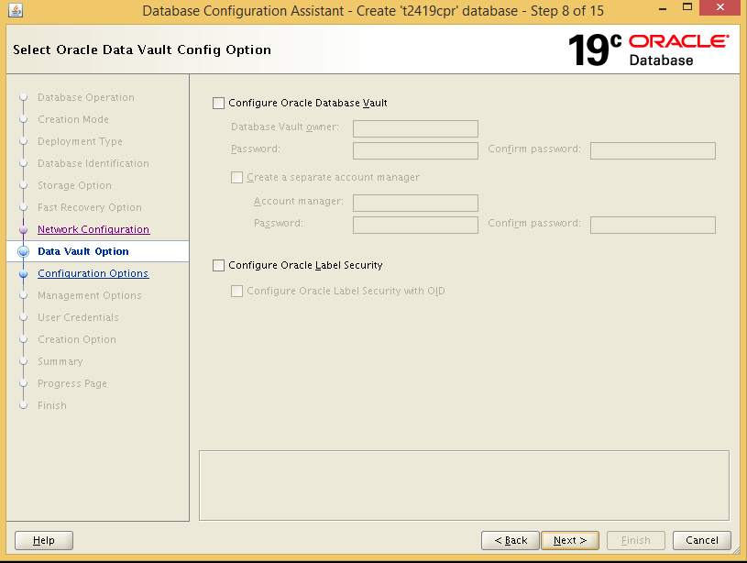

Within the Configuration Options window, ensure the Use Automatic Shared Memory Segment is selected, and use the scroll bar or enter the appropriate SGA and PGA values for the environment. The remaining tabs, Sizing, Character sets, Connection mode, the defaults are used.
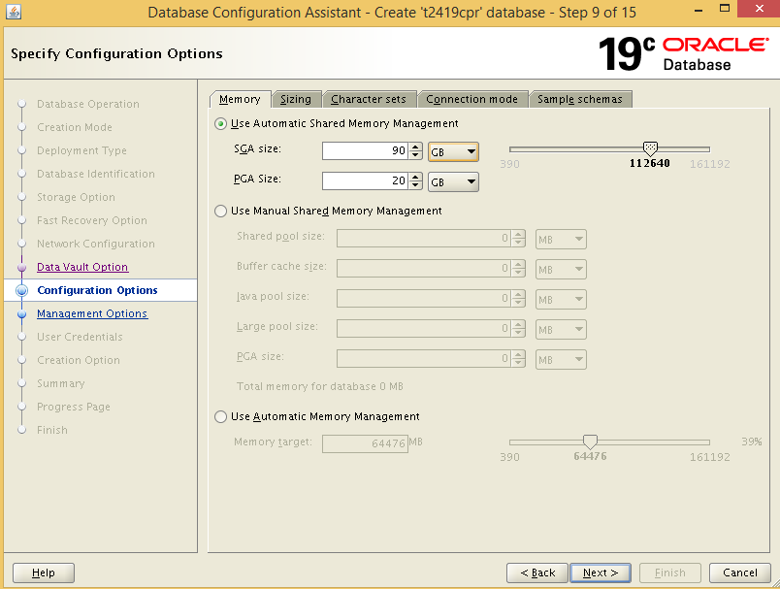
Within the Management Options window, modify the Enterprise Manager Database port or deselect Configure Enterprise (EM) database express if not being used. This reference architecture uses the defaults and selected Next.

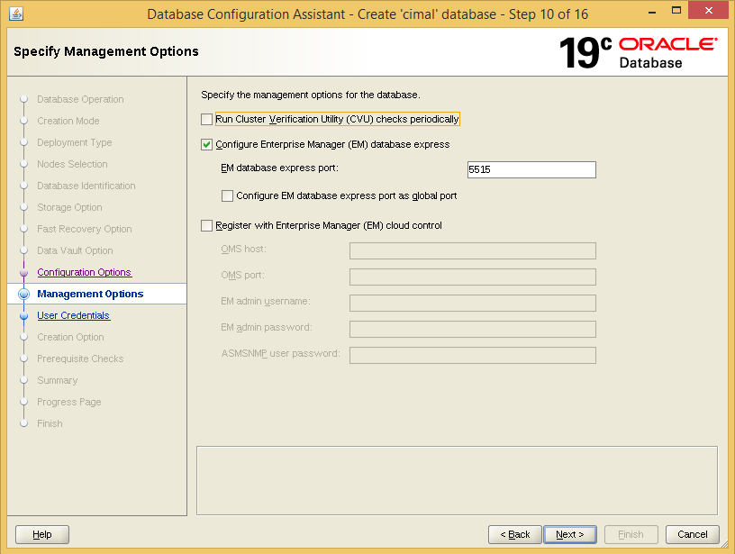
Within the User Credentials window, enter the credentials for the different administrative users and click Next.

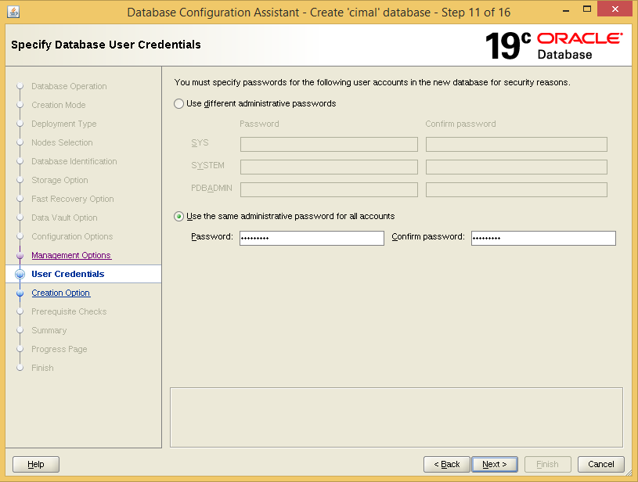

Within the Creation Option window, ensure the Create database checkbox is selected. This reference architecture uses the defaults for all other options, but may be customizable to fit an environment’s requirements.
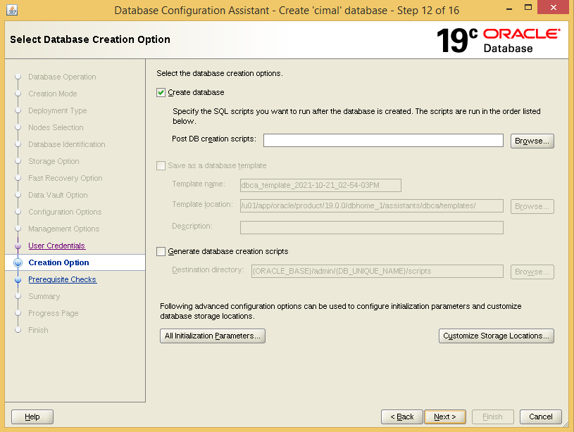

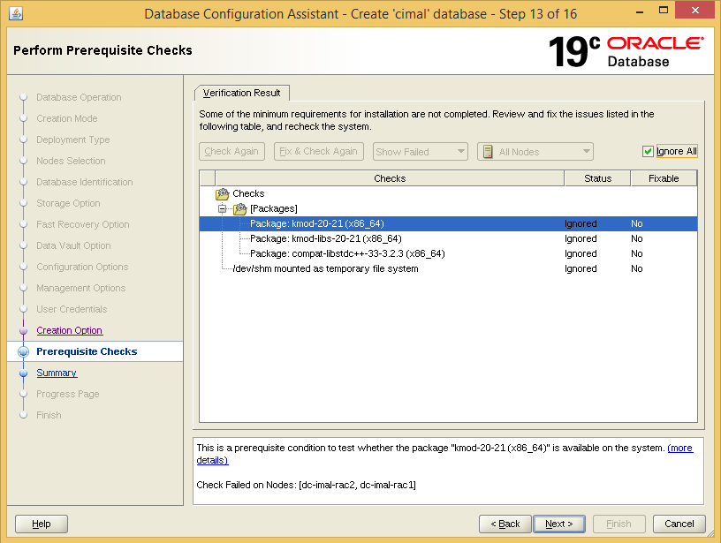

Within the Summary window, review the Summary, and click Finish. To start the database creation.
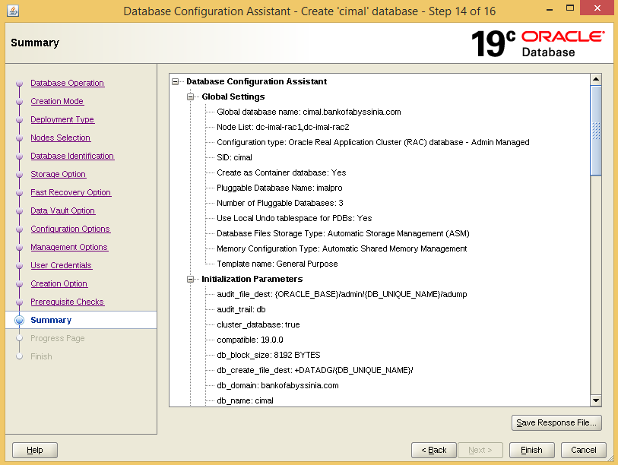

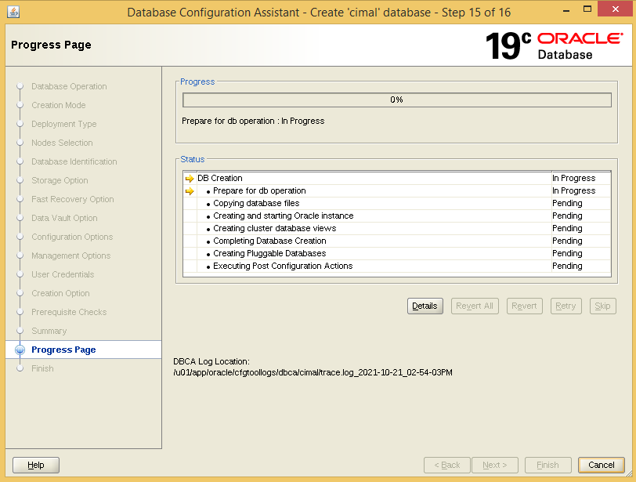

When database creation is done click Close to finish the database creation.

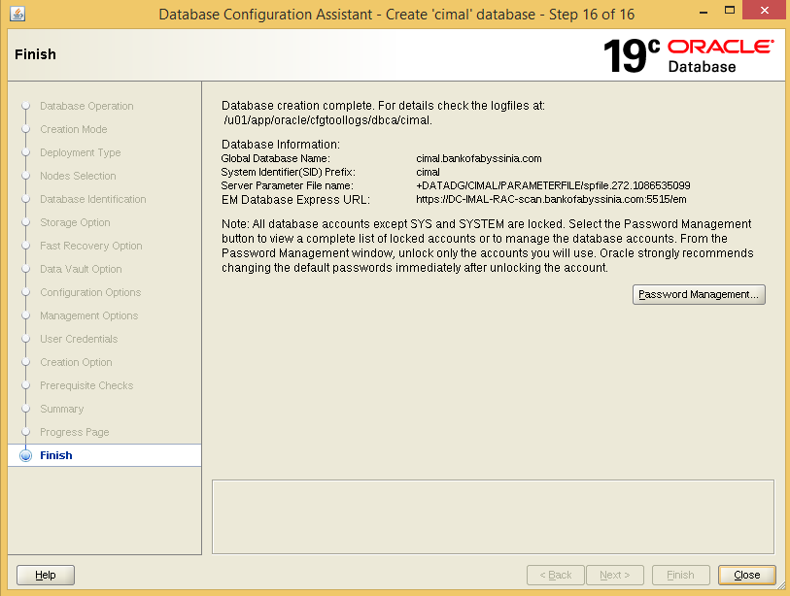

Recommendations for RAC environment
share the following files between the RAC databases:
- password file
- spfile
- dgbroker files
- autobackup location on RMAN configuration
- FRA location

e.g.
[oracle@DR-DW-RAC1 dbs]$ srvctl config database -d dwprod
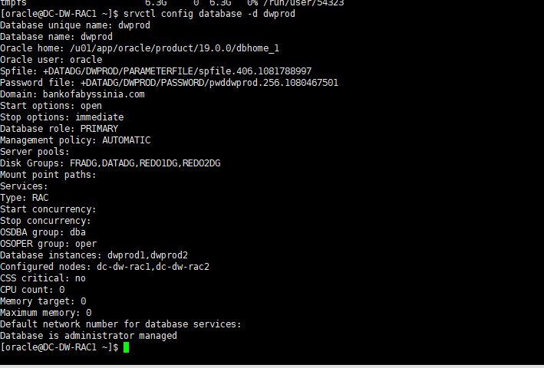

References
[1] https://oracle-base.com/articles/19c/oracle-db-19c-installation-on-oracle-linux-7
[2] https://access.redhat.com/documentation/en-us/reference_architectures/2017/html/deploying_oracle_database_12c_release_2_on_red_hat_enterprise_linux_7/index
[3] BoA other versions of Oracle deployment guides

